UNIVERSITY OF HAWAII
INSTITUTE FOR ASTRONOMY
2680 Woodlawn Dr.
Honolulu, HI
96822
NASA Infrared Telescope Facility
TCS3 SERVO SYSTEM: Proposed Design

Fred Keske
Version 1.2

1 Introduction 5
1.1 Modeling Package 5
1.2 Modeling Progression 5
2 Baseline Comparison Tests 5
2.1 Offset 5
2.2 Track 6
3 System Simulations 6
3.1 JPL System 6
3.1.1 Model Overview 6
3.1.2 Simulations 6
3.2 Present System 8
3.2.1 Model Overview 8
3.2.2 Simulations 10
3.2.3 Bode Plots 14
3.2.4 Frequency Sweep 17
3.3 Proposed System 18
3.3.1 Model Overview 18
3.3.2 Simulations 21
3.3.3 Bode Plots 32
3.3.4 Frequency Sweep 35
4 Servo Data from the Present System 37
4.1 Tracking 37
4.1.1 HA 37
4.1.2 Dec 39
4.2 Offset 41
4.3 Slew 43
4.4 External Disturbance 44
4.5 Velocity Loop Tests 45
5 Encoder Resolution 47
6 Summary 49
6.1 Resolution Requirements 49
6.2 Encoder Resolution 49
6.3 Tachometer Configuration 49
6.4 PID Parameter Values 50
6.5 Wind Loading 50
7 References 50

Figure 1 JPL Model 6
Figure 2 JPL Step 7
Figure 3 JPL Track 8
Figure 4 Present System 10
Figure 5 Present Tachometer Block 10
Figure 6 Present Step 12
Figure 7 Present Track without Wind 13
Figure 8 Present Track with Wind 14
Figure 9 Present System Response Testing 15
Figure 10 Present Open Loop Response 16
Figure 11 Present Closed Loop Response 17
Figure 12 Present System in Sweep Testing Mode 17
Figure 13 Present System Sweep Plot 18
Figure 14 Proposed System 20
Figure 15Proposed Tachometer Block 20
Figure 16 Proposed Step 8P, 2.1I 21
Figure 17 Proposed Step 35P, 2.8I 22
Figure 18 Proposed Step 50P, 2.8I 23
Figure 19 Proposed Step 100P, 2.8I 24
Figure 20 Proposed Track with Wind 8P, 2.1I 25
Figure 21 Proposed Track with Wind 35P, 2.8I 26
Figure 22 Proposed Track with Wind 50P, 2.8I 27
Figure 23 Proposed Track with Wind 100P, 2.8I 28
Figure 24 Proposed 15 arcsec/sec Positive Track without Wind 50P, 2.8I 29
Figure 25 Proposed 15 arcsec/sec Negative Track without Wind 50P, 2.8I 30
Figure 26 Proposed 30 arcsec/sec Positive Track without Wind 50P, 2.8I 31
Figure 27 Proposed Negative Track without Higher Frequency Velocity Compensation 32
Figure 28 Proposed System Response Testing 33
Figure 29 Proposed Open Loop Response 34
Figure 30 Proposed Closed Loop Response 35
Figure 31 Proposed System in Sweep Testing Mode 36
Figure 32 Proposed System Sweep Plot 37
Figure 33 Track Off 38
Figure 34 HA Track 15 38
Figure 35 West Track 30 39
Figure 36 Dec Track Off 40
Figure 37 Dec Track 15 40
Figure 38 HA 600 arcsec Offset 42
Figure 39 HA 1200 arcsec Offset 42
Figure 40 Dec 1200 arcsec Offset 43
Figure 41 HA Slew 44
Figure 42 Dec Slew 44
Figure 43 External Disturbance 45
Figure 44 Velocity Loop Disabled 46
Figure 45 Bandpass Disturbance Rejection Circuit Disabled 47
Figure 47 Encoder Resolution versus System Resolution Chart 49

Table 1 Encoder Resolution versus System Resolution 48

Introduction
Due to a number of unknowns concerning the operation of the control servo potion of the TSC3 design, it was determined that the best course of action would be to model and simulate the proposed servo for the new TCS. The areas of concern were:
- Meeting the overall resolution requirements.
- Determining the encoder resolution needed to meet the overall resolution requirement.
- Determining the tachometer configuration needed to meet the resolution requirement and to provide the necessary loop stability.
- Coming up with a set of PID values that will hopefully be close to the final values used on the actual telescope or at minimum would be used as a good starting point for the PID tuning.
- A platform to test the effects of wind loading.

Modeling Package
Originally the modeling package chosen was ModelQ which is produced specifically for simulating servo systems. Unfortunately, the ModelQ package doesn’t have the capability to model complex mechanical systems. It was then decided that we would use the Matlab/Simulink package which has much more capabilities than the ModelQ software.

Modeling Progression
The method in which this project was approached was to firstly digest the original JPL dynamic analysis document (see reference 1) and extract the information to build the mechanical model (see reference 2), and also extract some encoder and tachometer gain information. Then we built the simple one motor JPL model in Matlab/Simulink and tested it to make sure it made sense. The two-motor mechanical model with six degrees of freedom was then built along with the present servo system based on the telescope schematics (see reference 3 and 4). The simulation was compared to actual data from the telescope for validity. Finally, the proposed servo system was built in Simulink and simulated using the present servo system simulation results as a baseline. An additional disturbance input was added to the mechanical model for wind loading simulations.

Baseline Comparison Tests
The servo system was simulated in two basic modes, offset and track. The two modes were used as baselines to compare systems and the variable parameters such as the PID values. When a parameter was changed, both of these tests needed to be run in succession to verify the effect on the system.

Offset
The offset was simulated as a 10 arcsec step. A step function is a worst-case stress test for a control system, something that would probably not be experienced in actual operation. This test shows what the absolute worst case overshoot and settling time of a system would be. It was found the a 10 arcsec step would extrapolate out to any size step, the resulting overshoot and settling time minus the initial step time would be the same for any size step. Optimization of the settling time while limiting the amount of overshoot is the goal. Since we don’t have a hard requirement for settling time, a self-imposed constraint of 2 seconds to be within 0.1 arcsec was the settling objective.

Track
A rate of 15 arcsec/sec was used as the baseline track rate. An RMS meter block was used to compare the desired versus actual position to get the overall RMS error in arcsecs. The RMS meter was started after tracking had been running for one second to eliminate the initial startup error to prevent the meter from winding up too high. The error drops to a fairly constant rate after about 10 seconds of simulation time without wind disturbance. Therefore, 10 seconds of simulation time was use for the baseline comparison. The goal, of course, is to optimize the system to reduce the RMS error.

Wind loading disturbance simulations were based on a wind spectra plot produced by Gemini for Mauna Kea (see reference 5) and from Tim’s analysis (see reference 2).

System Simulations

JPL System

Model Overview
The JPL model is shown below. It is a basic system that was meant to get a general idea as to how the telescope would be controlled.
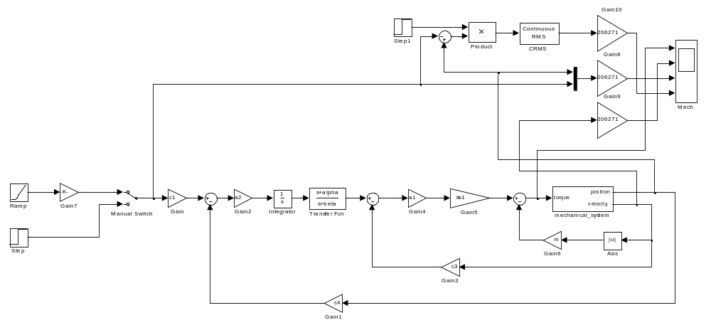
Figure 1 JPL Model

Simulations
Shown in the figures below are the results of a 10 arcsec step simulation and a 15 arcsec/sec tracking simulation for the JPL model. For the step function, the system settles out to 0.1 arcsecs in about 2.3 seconds though with quite a bit of overshoot. The tracking simulation has an RMS error of about 0.014 arcsecs which is good; however there are no digital components involved which mean there are no quantization errors to reduce the resolution.
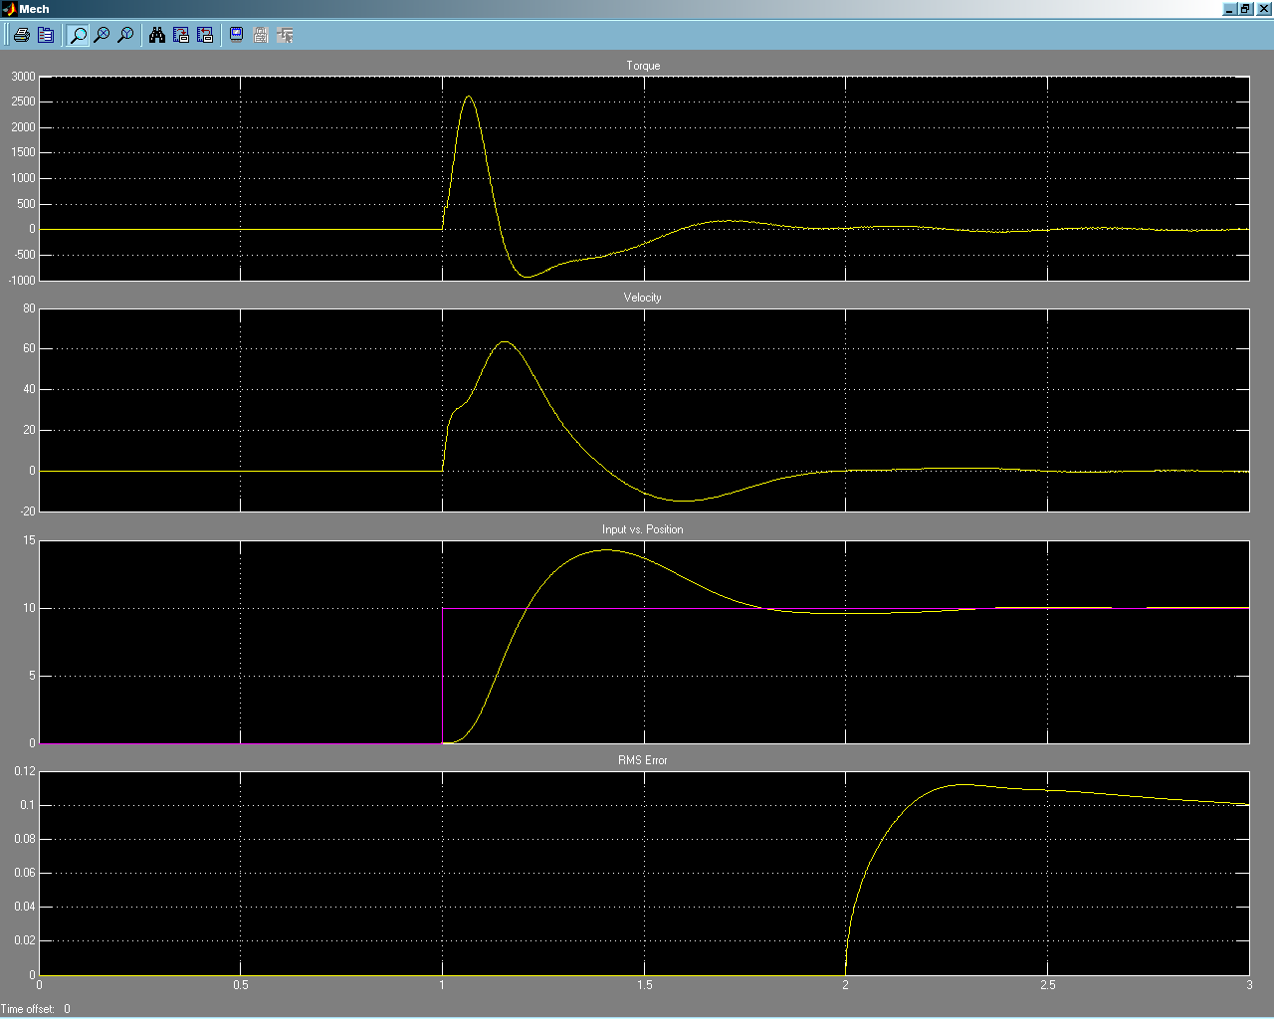
Figure 2 JPL Step
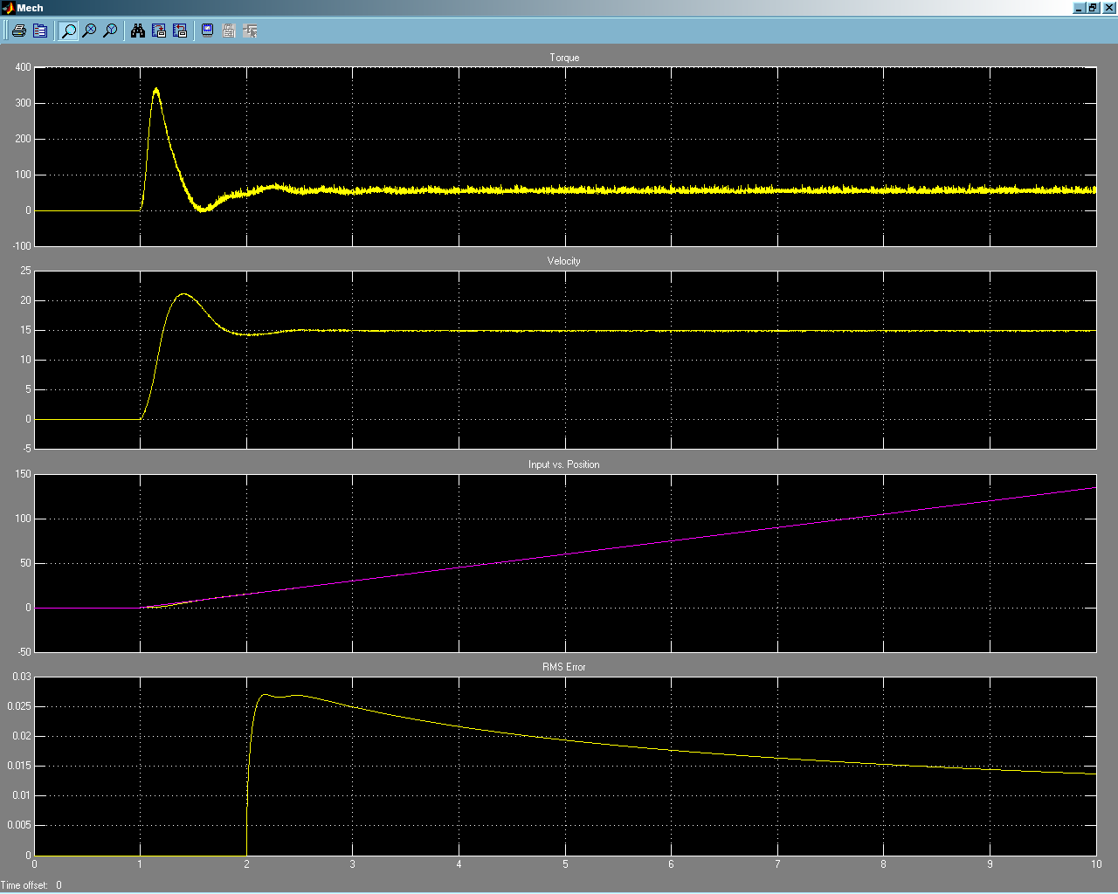
Figure 3 JPL Track

Present System

Model Overview
This model is an expansion of the JPL model with all of the filter transfer functions and the digital quantization blocks added. Note the block labeled quantizer 1 is a point of contention. This block represents spreading of the 10 Hz update to the PEC. It is not known for certain what the spreading frequency actually is since it set by software and possibly may be based on the track rate. What we do have to go on is a hand written note and timing diagram on a schematic that indicated for a 15 arcsec/sec track rate, the spreading frequency is nearly 300Hz. Therefore for lack of any other information, a spreading frequency of 300Hz is used in the simulation of the present system. This actually provides a conservative simulation baseline when performing comparisons to the proposed system.

The C3 and C4 gains were changed as outlined below from the original JPL document to represent values from the actual DAC, encoder, and tachometer resolutions used in the present system.

Calculation of C3 Gain
The C3 gain in the model represents the sensitivity of the tachometer present in the velocity loop. It has been recalculated as follows for the present system:
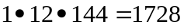Volt seconds/Radian
The original JPL calculation combined both tachometers into the same equation in their simplified single velocity loop model, therefore the number of tachometers parameter is set to two for the JPL model. In the present system, we separate the two velocity loops since we are using a two-motor model, therefore we set the number of tachometers parameter to one for the present system model.

Calculation of C4 Gain
The C4 gain in the model represents the sensitivity of the encoder present in the position loop. It has been recalculated as follows for the present system:
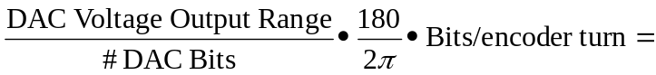
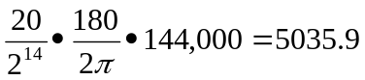Volt/Radian
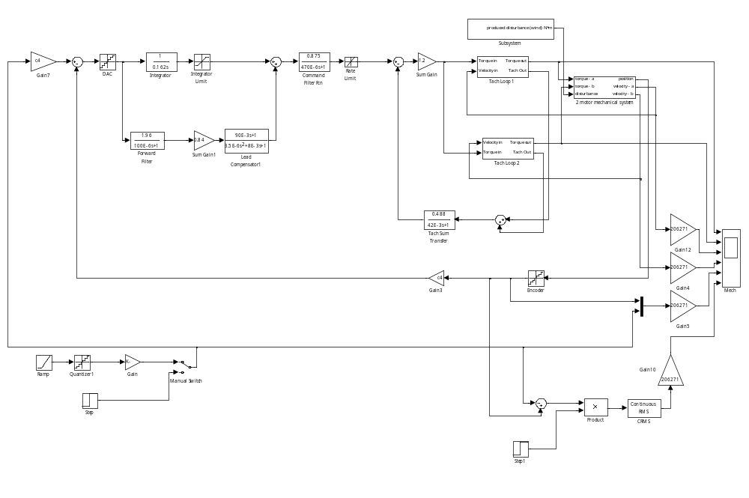
Figure 4 Present System
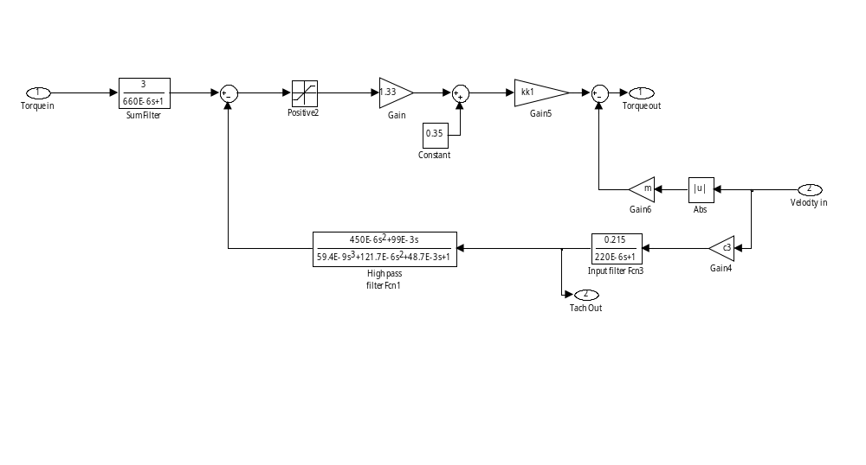
Figure 5 Present Tachometer Block

Simulations
Shown in the figures below are the results of a 10 arcsec step simulation, a 15 arcsec/sec tracking simulation without the wind disturbance, and a 15 arcsec/sec tracking simulation with the wind disturbance. For the step function we see that the system settles in about 2.25 seconds with an overshoot that matches closely with JPL simulation. The tracking simulation without the wind has an RMS error of 0.018 arcsecs and with the wind we have an RMS error of 0.16 arcsecs.

As can be seen in the simulations there is a fair amount of noise when compared to the JPL model. This is most likely due to the fact that mechanical model is the more realistic dual opposing motor version.
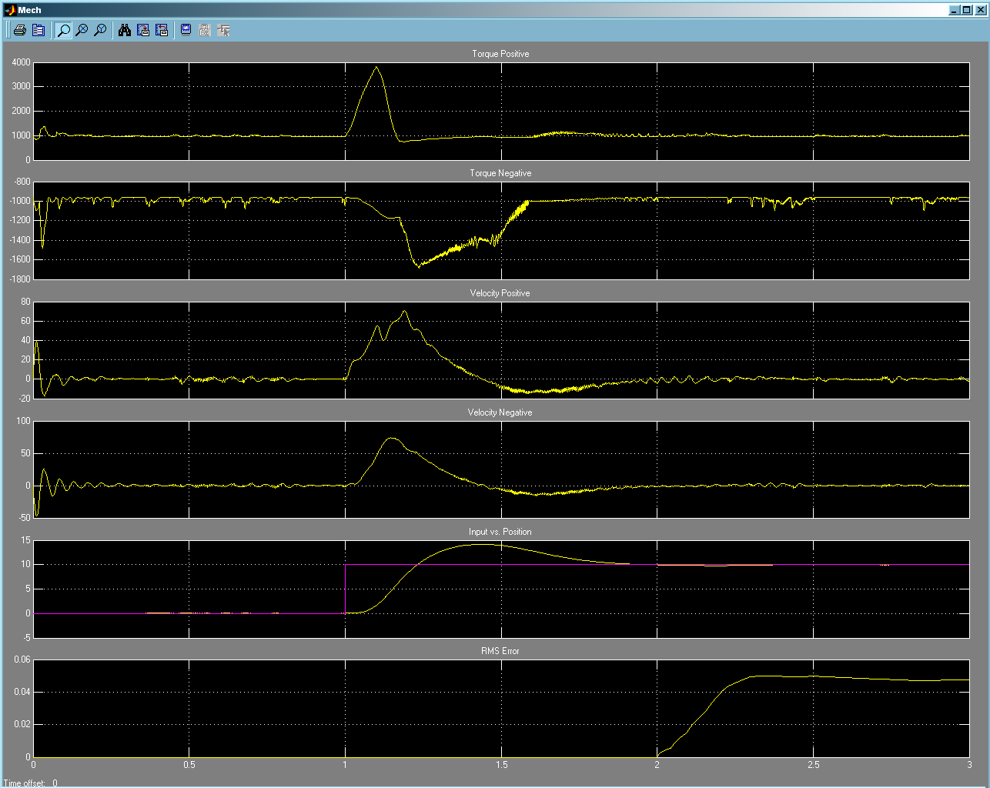
Figure 6 Present Step
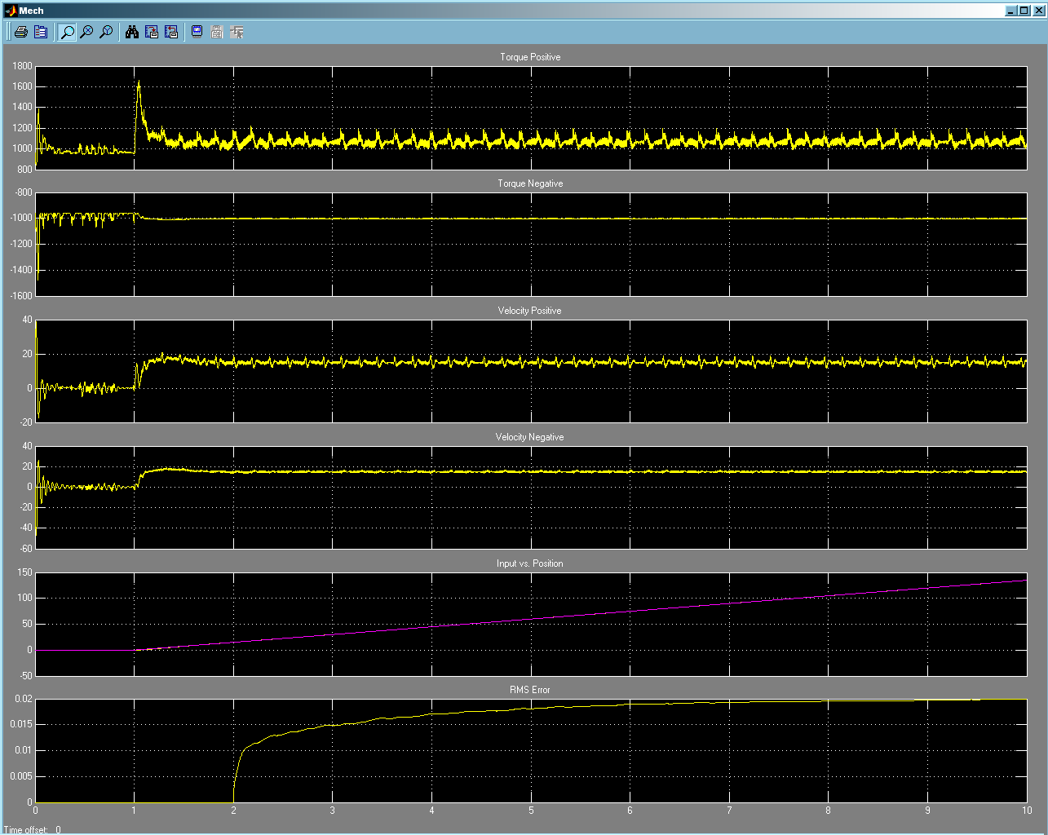
Figure 7 Present Track without Wind
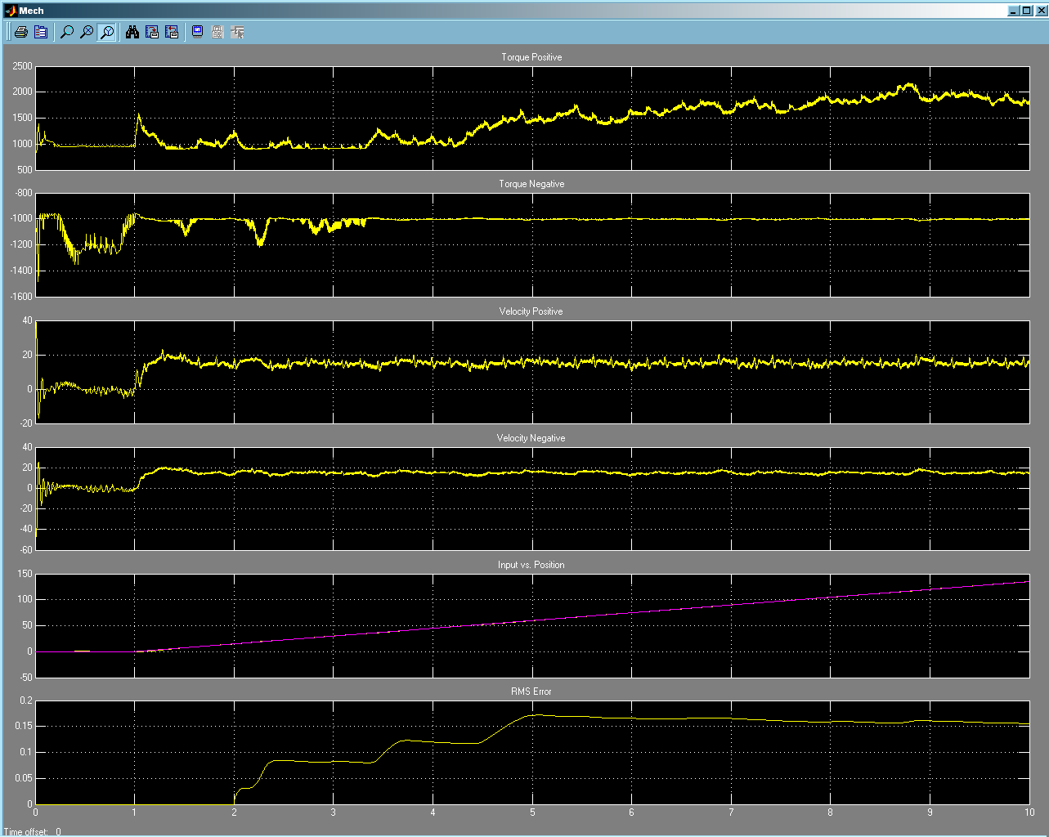
Figure 8 Present Track with Wind

Bode Plots
The figure below shows the placement of the spectrum analyzer blocks used to create open and closed loop system response plots.
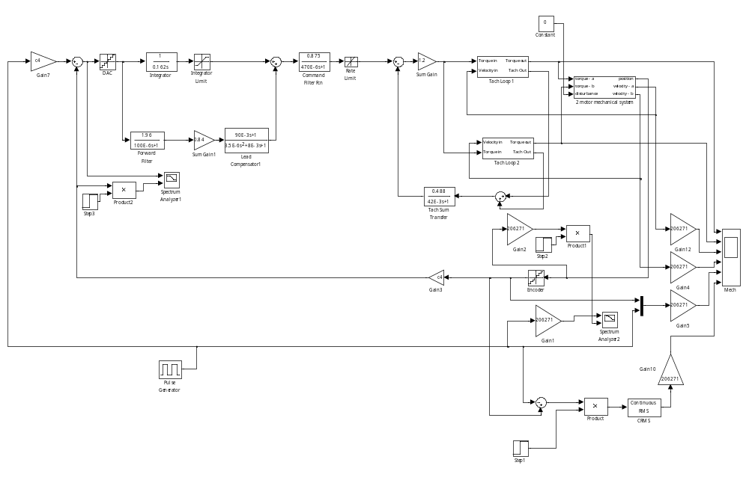
Figure 9 Present System Response Testing

Open Loop Bode Plot
The figure below shows an open loop Bode plot for the present system. Notice the phase at the 0db point (gain of 1) which is at approximately 9.5Hz. The phase margin at this point is approximately 20° which is usually considered too small of amount of margin. A margin of at least 35° is desirable.
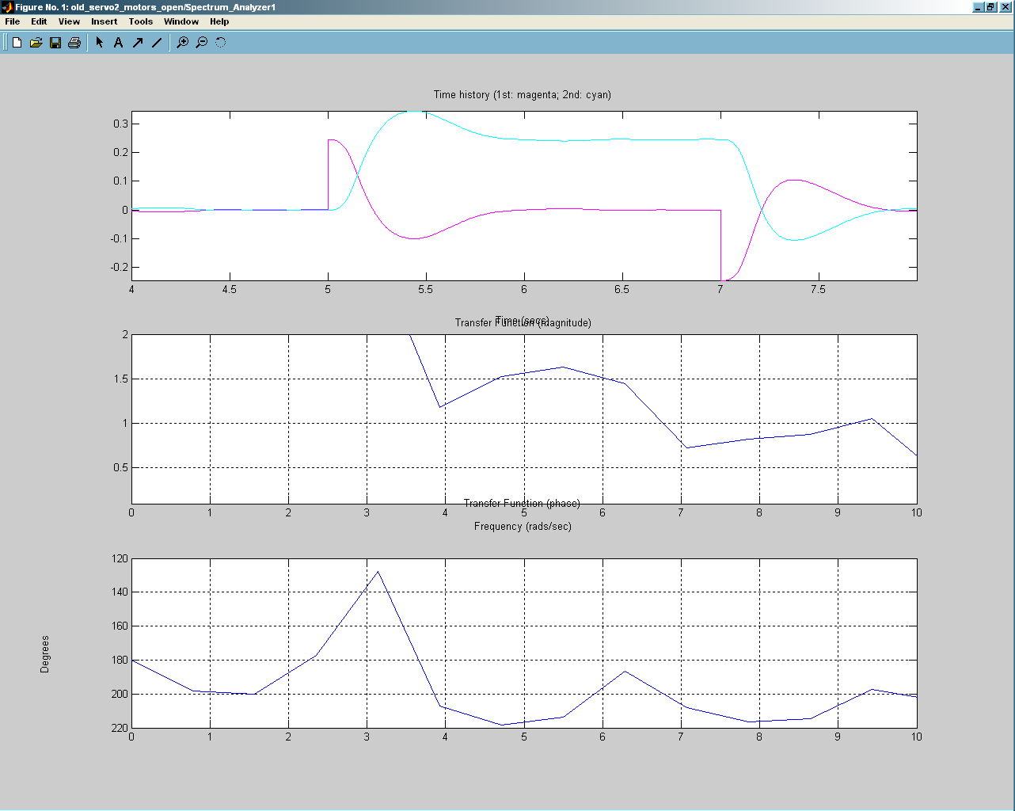
Figure 10 Present Open Loop Response

Closed Loop Bode Plot
The figure below shows the closed loop response of the system. The 3db point (0.707) is at approximately 115Hz with the phase shift around the -180° area which again shows the marginal stability of the system.
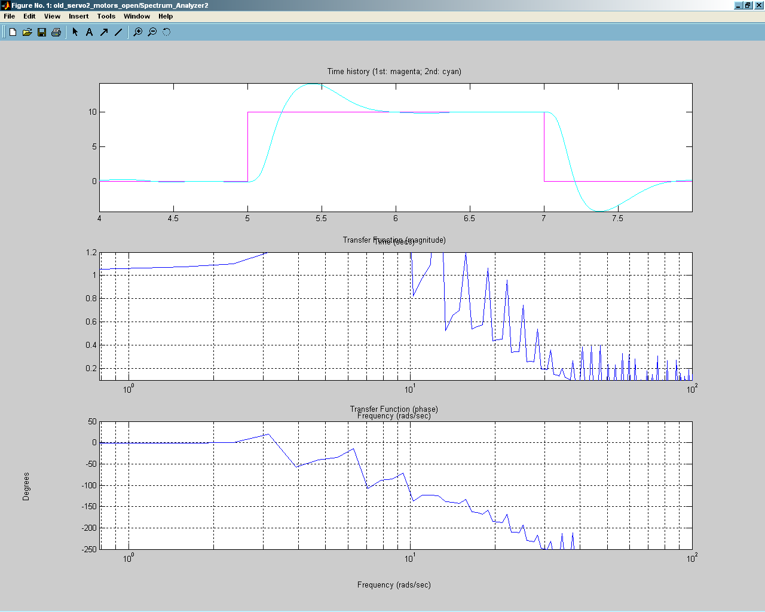
Figure 11 Present Closed Loop Response

Frequency Sweep
The figure below shows the placement of the spectrum analyzer block and the “chirp” sweep block used to create the open loop frequency sweep plot.
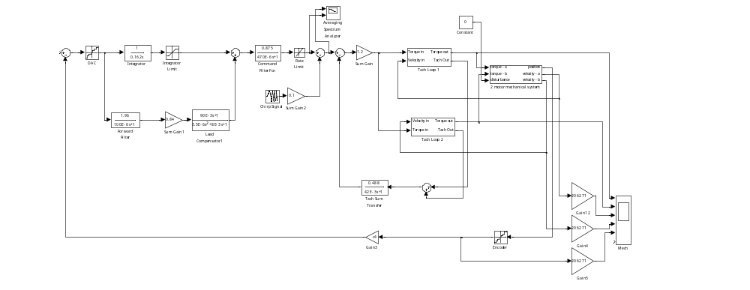
Figure 12 Present System in Sweep Testing Mode
The figure below shows the plot of the frequency sweep. The sweep was from 0.1Hz to 100Hz over 500 seconds. There is a slight amount of gain in the lower frequency range, however above 1Hz, the gain is near unity. We do start to see some phase change above 100Hz, but once again it’s minimal and outside the operating range of the system.
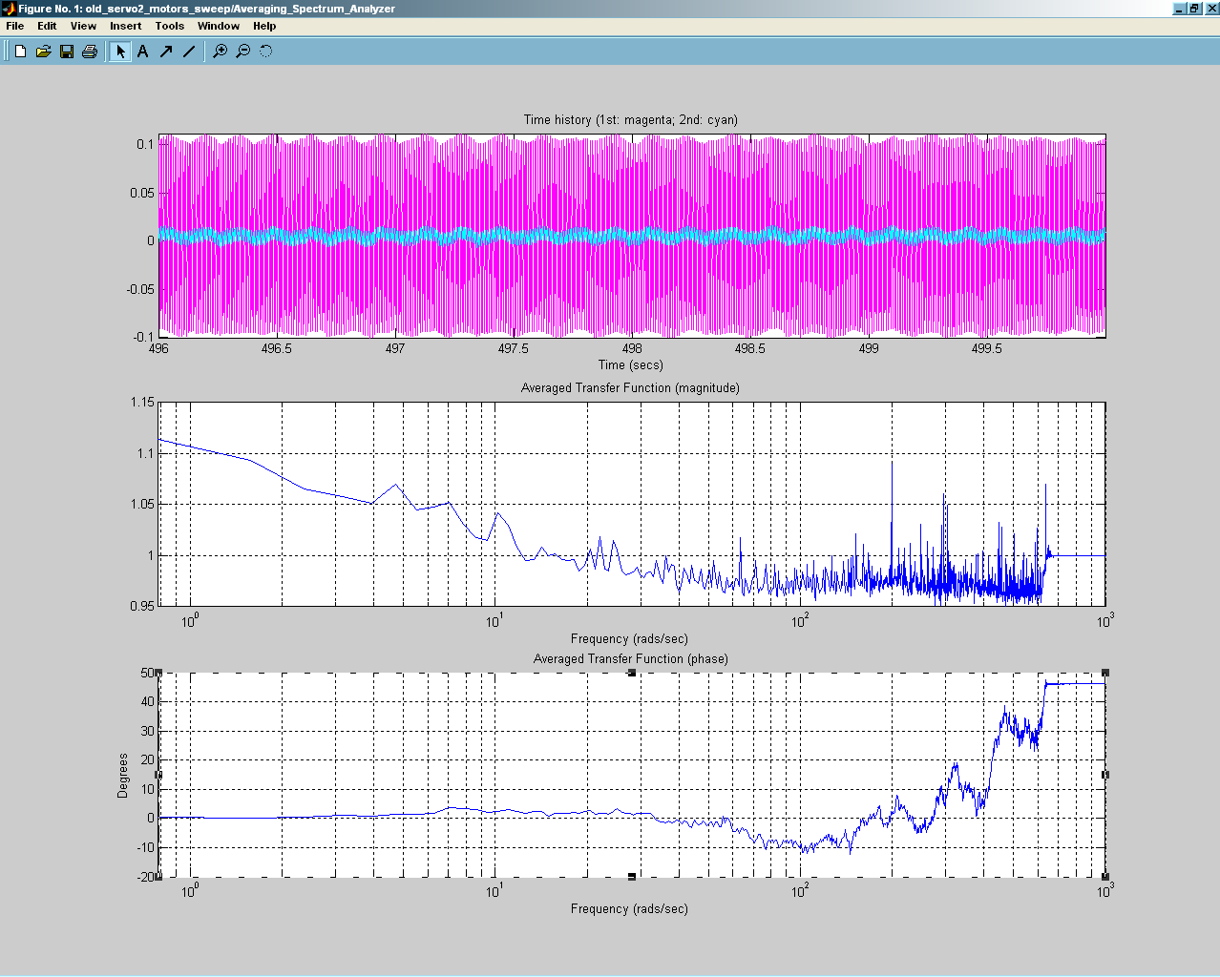
Figure 13 Present System Sweep Plot

Proposed System

Model Overview
The proposed system model is shown in the two figures below. The second figure is one of the tachometer blocks. The PID control section is based on the proposed DeltaTau PMAC motor controller. The motor velocity section is a modified version of the dual tachometer configuration used on the present system. The two tachometers (one for each motor) are summed together in which the signal is then routed into an ADC on the PMAC to be used for motor velocity. The resulting velocity output from the PMAC is summed with the high pass filter disturbance circuit that is identical to the present system.

The C3 and C4 gains were changed as outlined below from the original JPL document to represent values from the actual DAC, encoder, and tachometer resolutions used in the proposed system.

Calculation of C3 Gain
The C3 gain in the model represents the sensitivity of the tachometer present in the velocity loop. It has been recalculated from the JPL model as follows for the proposed system which is the same as for the present model and is repeated here:
Volt seconds/Radian
The original JPL calculation combined both tachometers into the same equation in their simplified single velocity loop model, therefore the number of tachometers parameter is set to two for the JPL model. In the present system, we separate the two velocity loops since we are using a two-motor model, therefore we set the number of tachometers parameter to one for the present system model.

Calculation of C4 Gain
The C4 gain in the model represents the sensitivity of the encoder present in the position loop. It has been recalculated as follows for the proposed system:
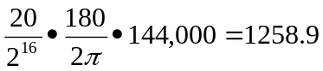Volt/Radian

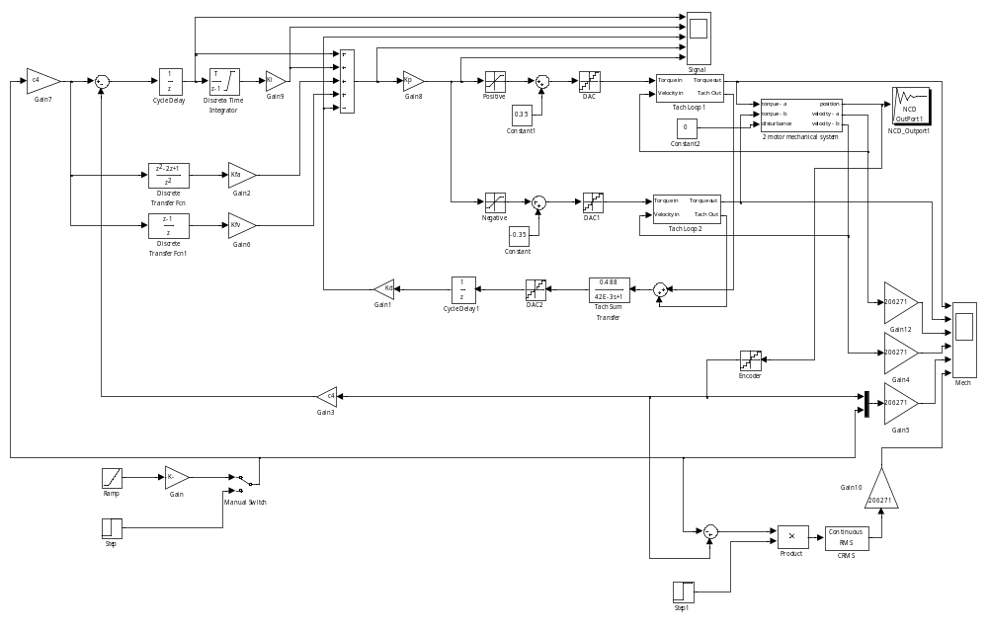
Figure 14 Proposed System
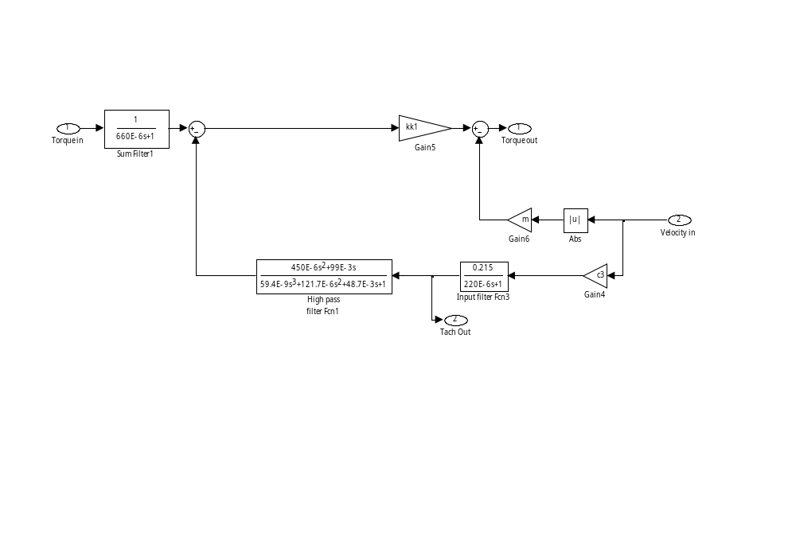
Figure 15Proposed Tachometer Block

Simulations
The simulations for the proposed system were run at four different gain values for Proportional term with the Integral term set slightly lower with the lowest Proportional term. The optimal value for the Derivative which was found to be relatively consistent across all simulations is 0.65.

Step Function
For the step, the optimal Proportional value is at the low end which was found to be a value of 8 with an Integral of 2.1. This is shown in the first figure.
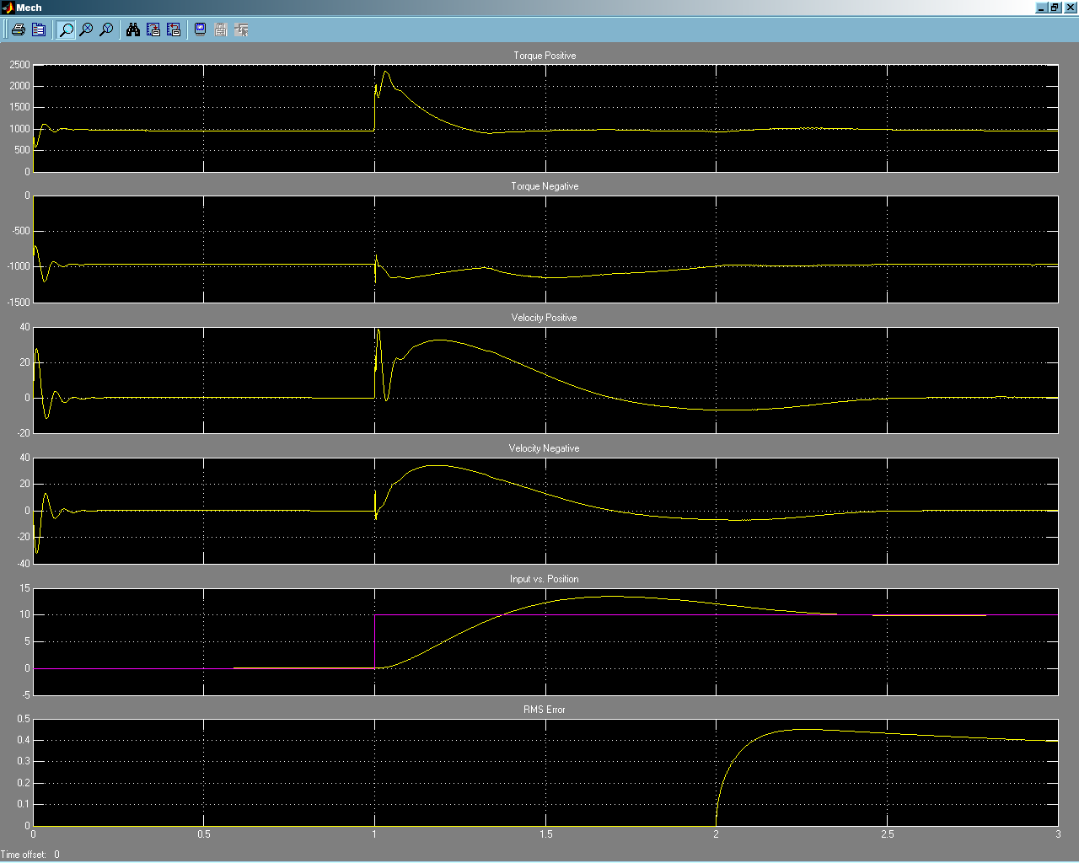
Figure 16 Proposed Step 8P, 2.1I
The next figure shows the simulation run with the Proportional term increased to 35 and the Integral increased to 2.8. Notice the slight “hump” in the acceleration ramp.
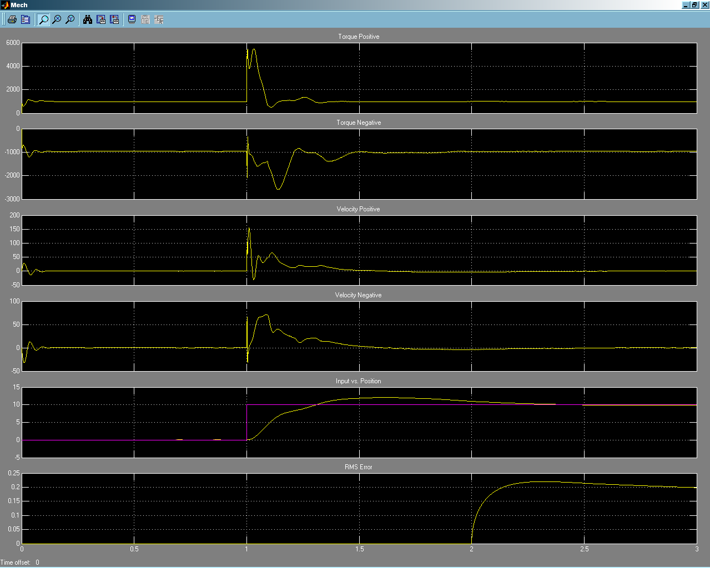
Figure 17 Proposed Step 35P, 2.8I
The following figure shows the simulation run with the Proportional term increased to 50. Notice there are now two “humps” in the acceleration ramp.
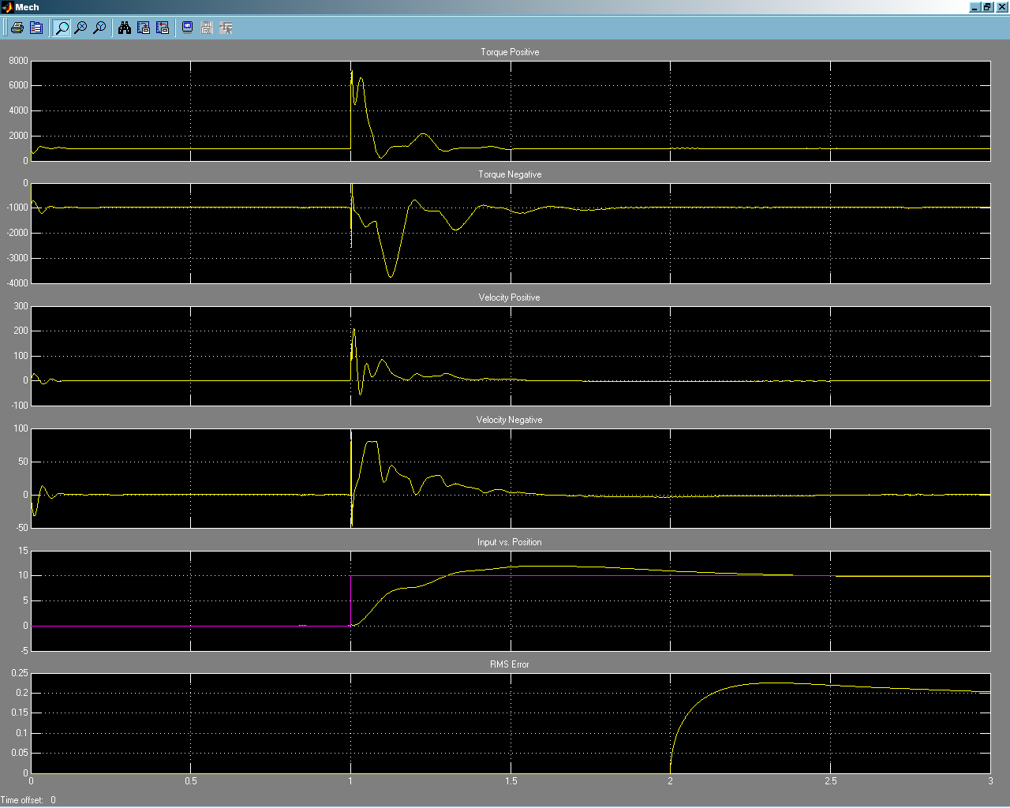
Figure 18 Proposed Step 50P, 2.8I
The last figure shows the simulation run with the Proportional term increased to 100. Notice there is now a number of “humps” in the acceleration ramp. Also, notice there is damped oscillations in the torque and velocity charts.
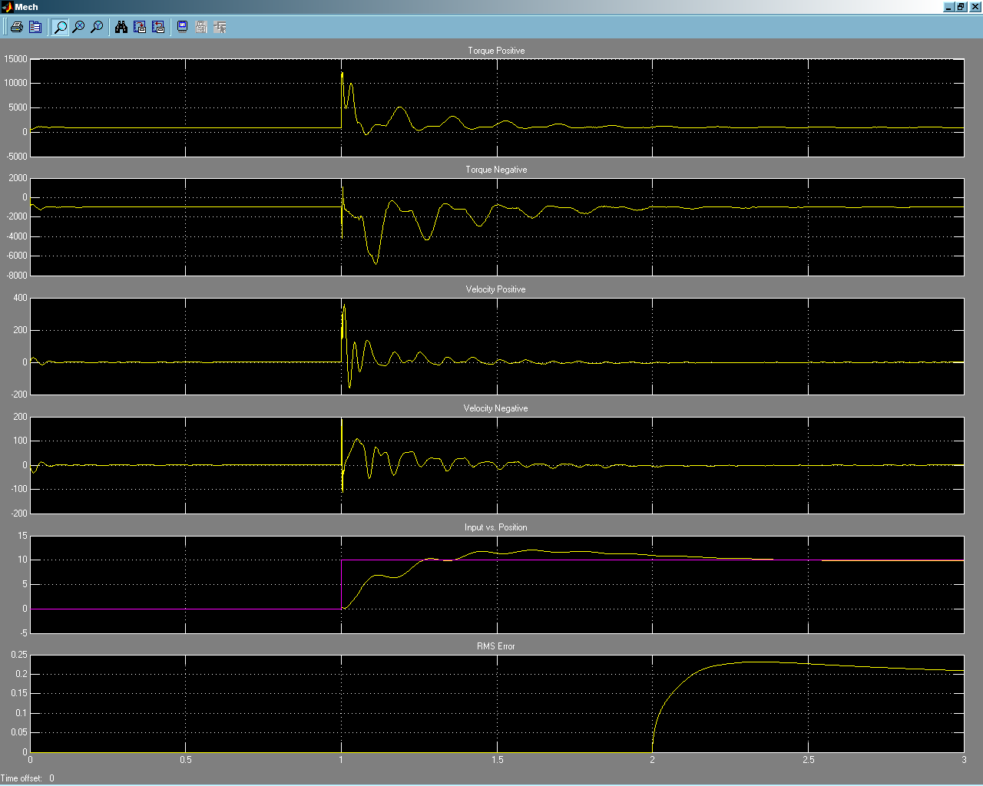
Figure 19 Proposed Step 100P, 2.8I

Tracking with Wind Disturbance
The first figure shows the tracking simulation run with a Proportional term set to 8. The RMS error is seen to be about 0.65 arcsecs.
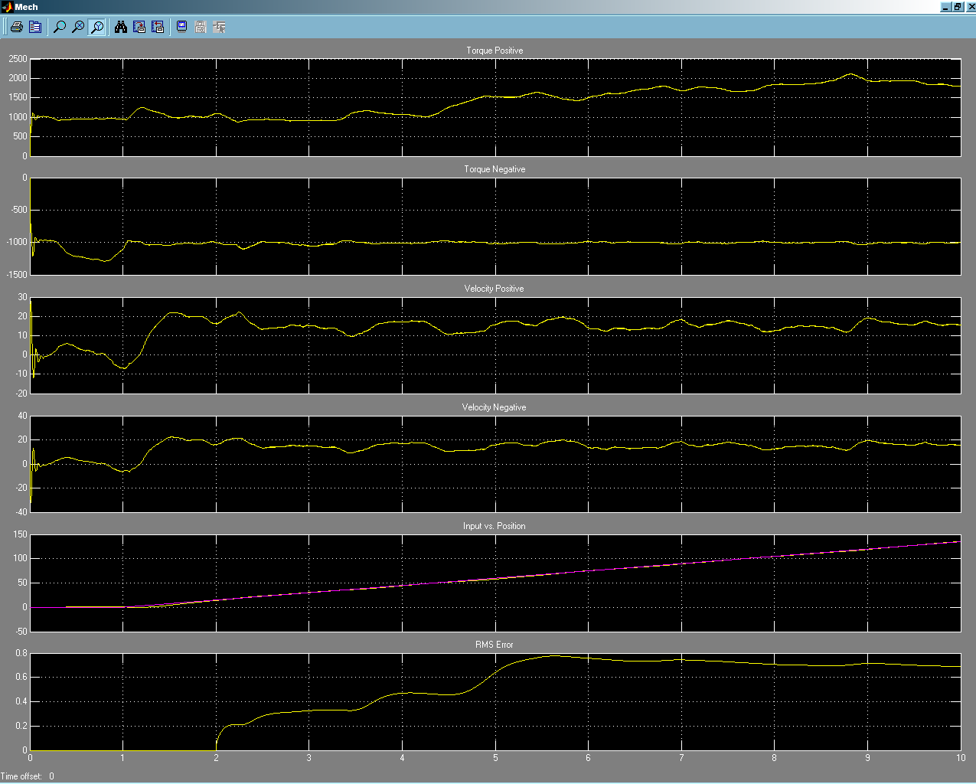
Figure 20 Proposed Track with Wind 8P, 2.1I
The next figure shows the tracking simulation run with a Proportional term set to 35. The RMS error is seen to be at 0.2 arcsecs.
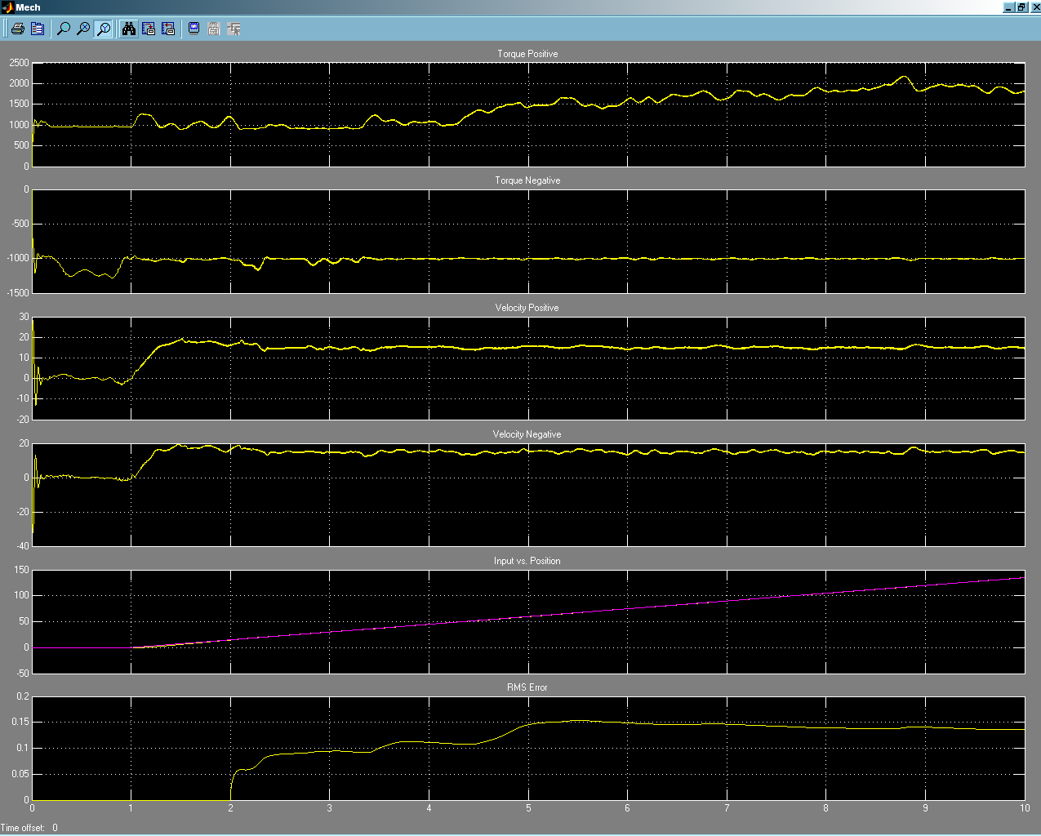
Figure 21 Proposed Track with Wind 35P, 2.8I
The next figure shows the tracking simulation run with a Proportional term set to 50. The RMS error is seen to be at 0.14 arcsecs.
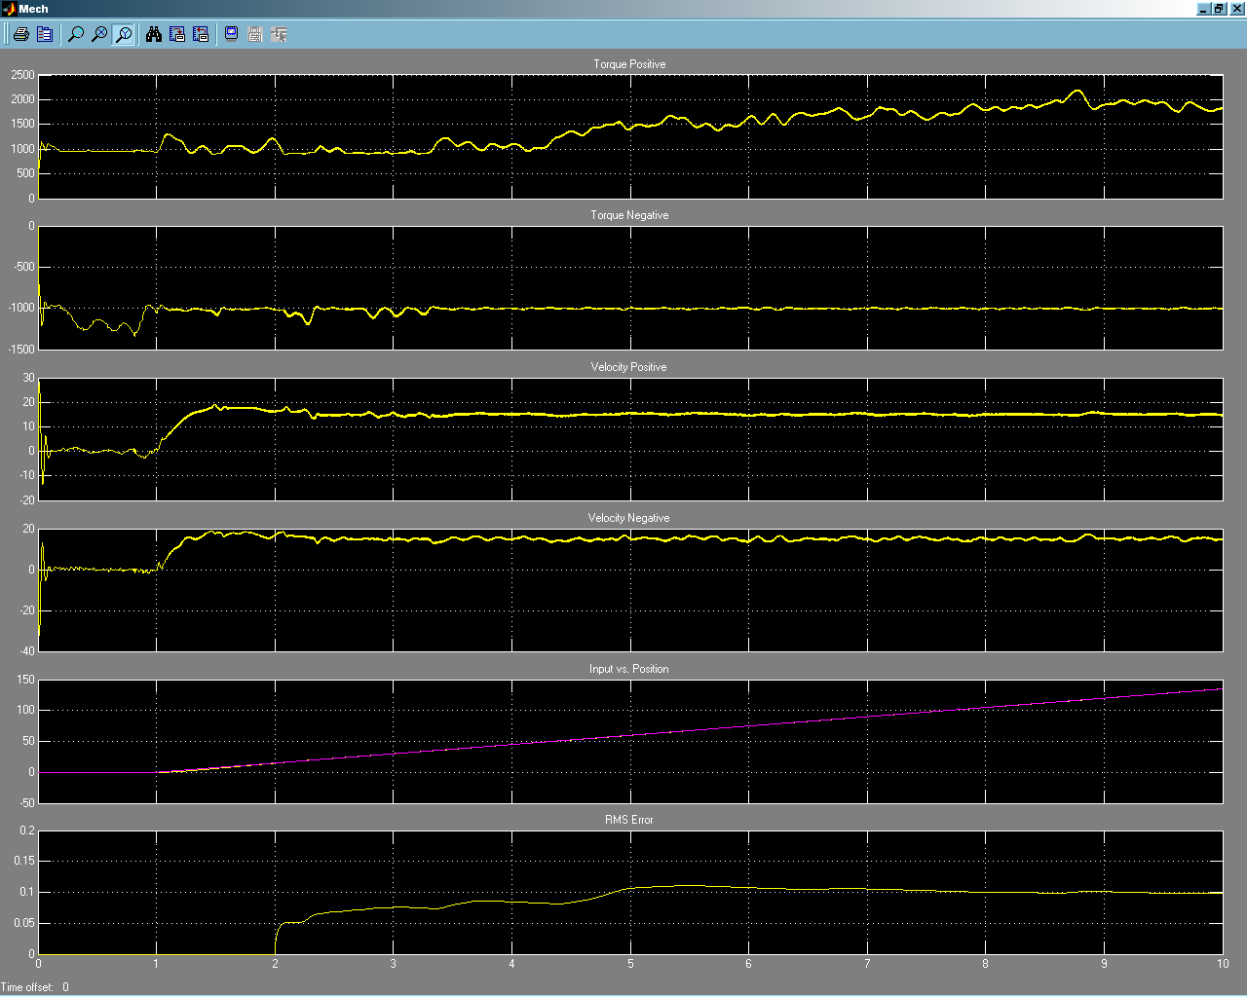
Figure 22 Proposed Track with Wind 50P, 2.8I
The next figure shows the tracking simulation run with a Proportional term set to 100. The RMS error is seen to be at 0.06 arcsecs.
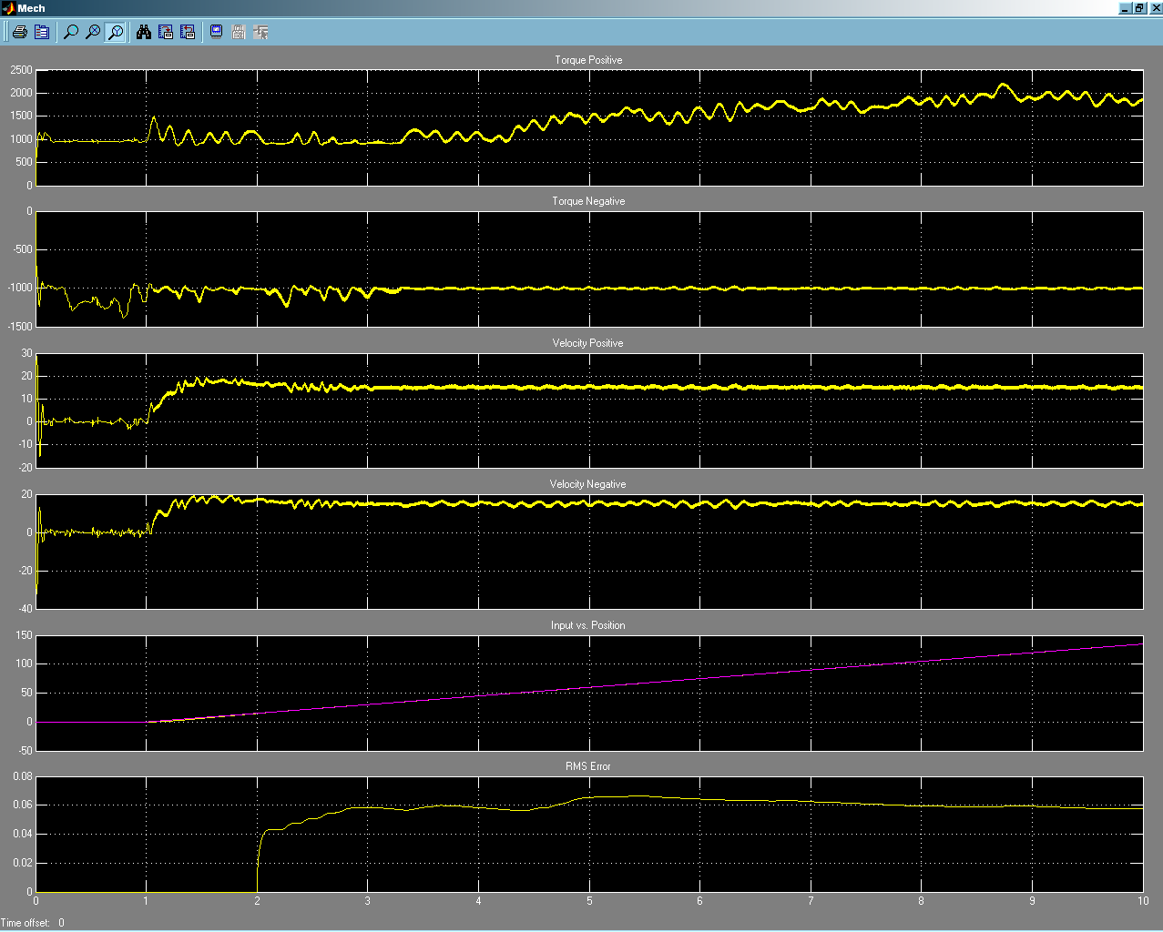
Figure 23 Proposed Track with Wind 100P, 2.8I

Tracking with no Disturbance
The following three figures show the system run with no wind disturbance with the Proportional term set to 50 and the Integral term set to 2.8. The first figure shows a positive track with an RMS error of 0.03 and the next one show a negative track with an RMS error of 0.25 and the last figure shows a track rate of 30 arcsecs/sec with an RMS error of 0.054.
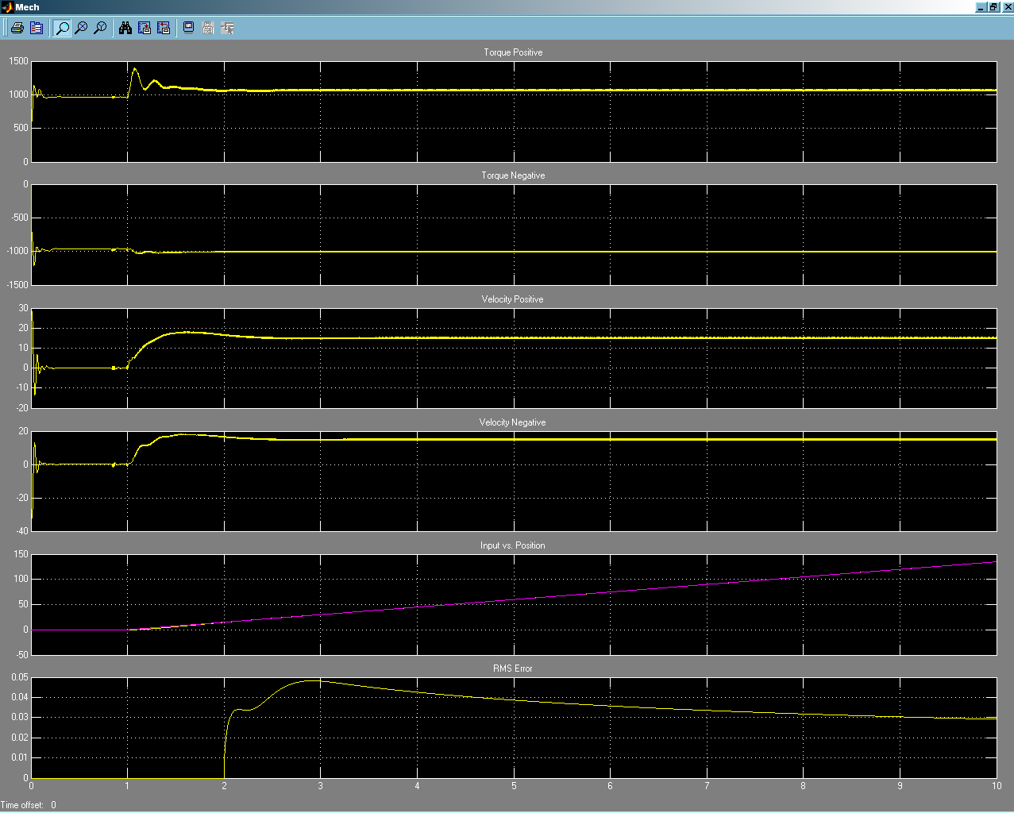
Figure 24 Proposed 15 arcsec/sec Positive Track without Wind 50P, 2.8I
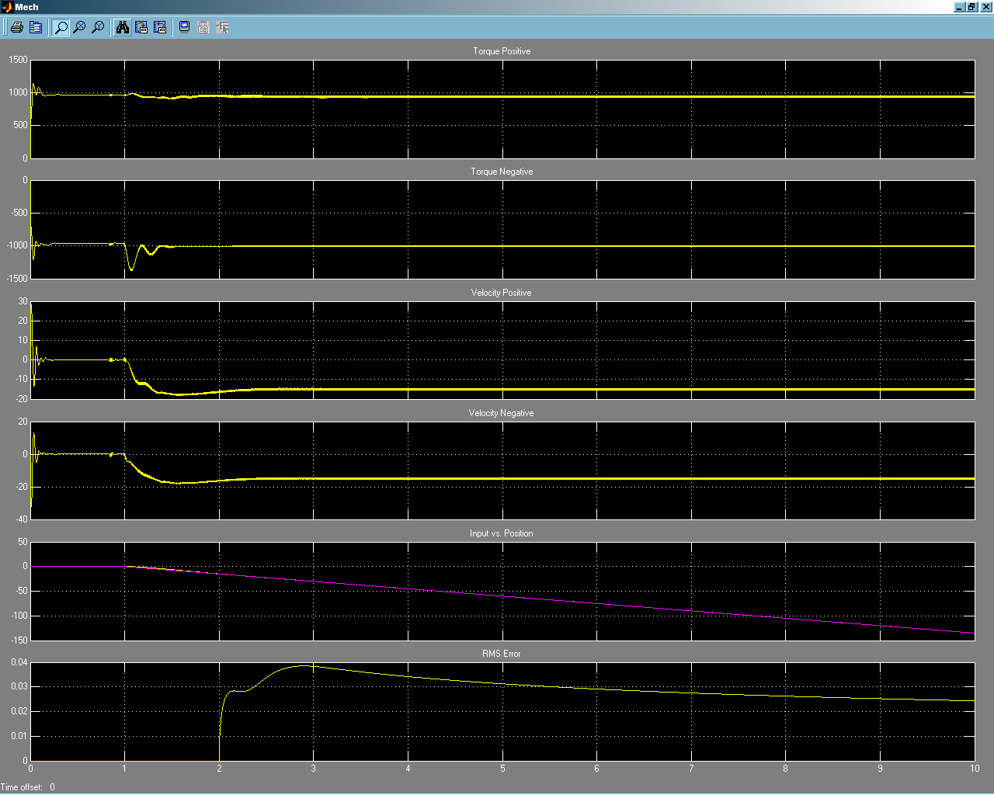
Figure 25 Proposed 15 arcsec/sec Negative Track without Wind 50P, 2.8I
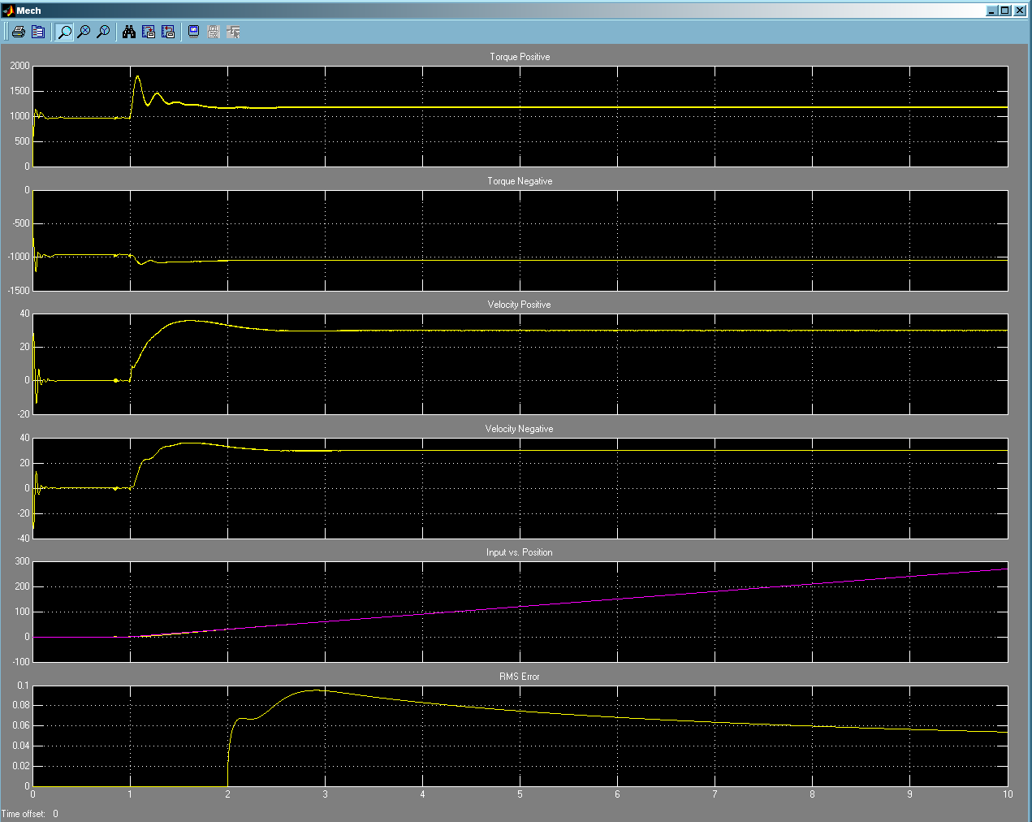
Figure 26 Proposed 30 arcsec/sec Positive Track without Wind 50P, 2.8I

Tracking without Velocity High Frequency Noise Compensation
The following figure shows the effect of the high frequency noise compensation circuit disabled. As can be seen in the figure, undamped noise is present in the torque and velocity axis. The system is still somewhat controllable; however, the RMS error is at 2.5 arcsecs. This event only occurs in the negative track direction within the model. The circuit used is actually a bandpass filter with the passband being from 8.6Hz to 34.4Hz. The same circuit is used on the present system.
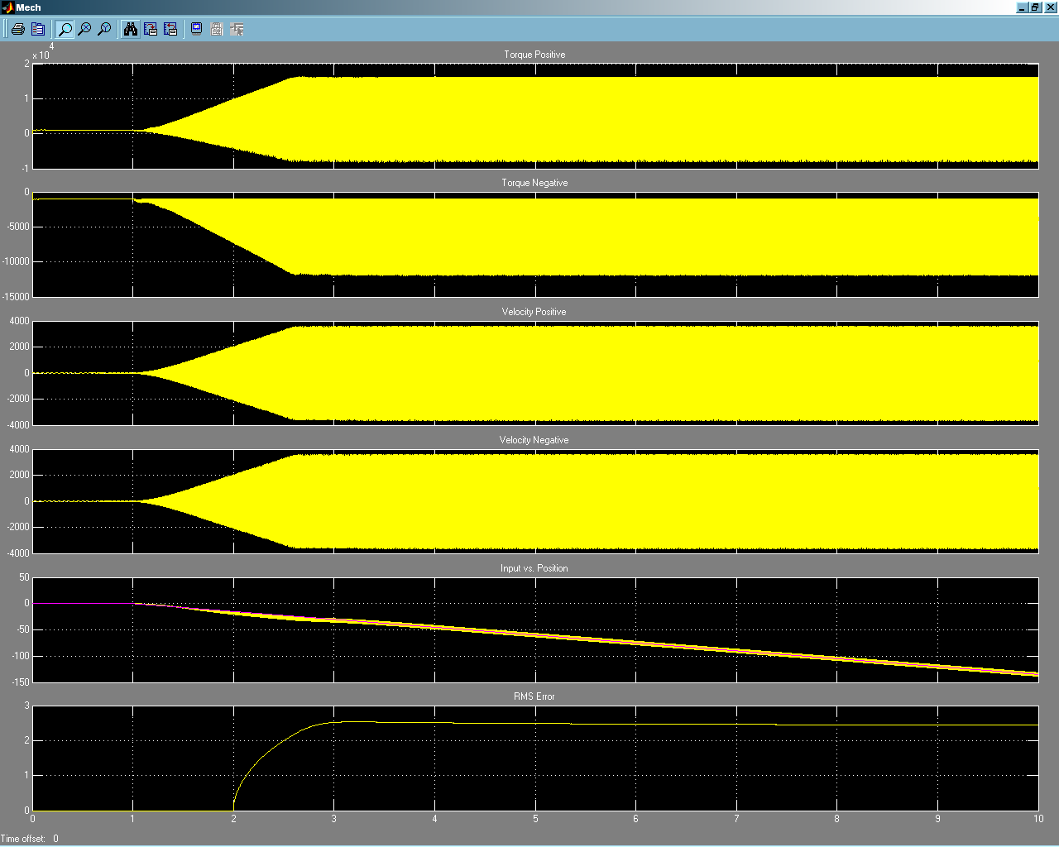
Figure 27 Proposed Negative Track without Higher Frequency Velocity Compensation

Bode Plots
The figure below shows the placement of the spectrum analyzer blocks used to create open and closed loop system response plots.
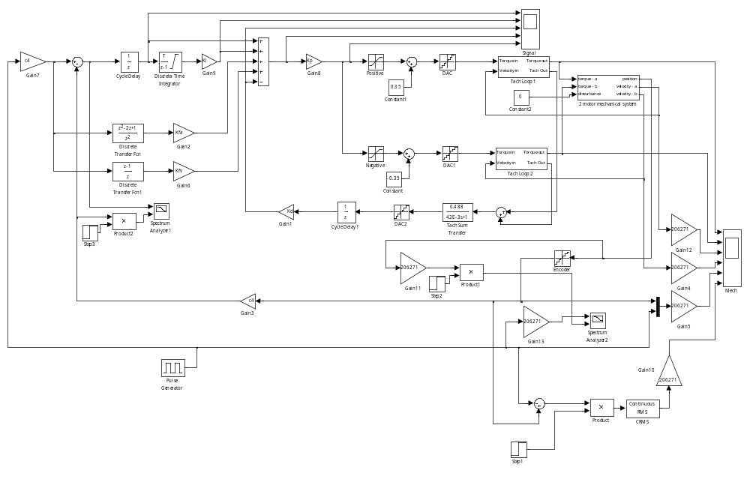
Figure 28 Proposed System Response Testing

Open Loop Bode Plot
The figure below shows an open loop Bode plot for the proposed system. Notice the phase at the 0db point (gain of 1) which is at approximately 9.5Hz. The phase margin is approximately 50° which is a decent amount of margin.
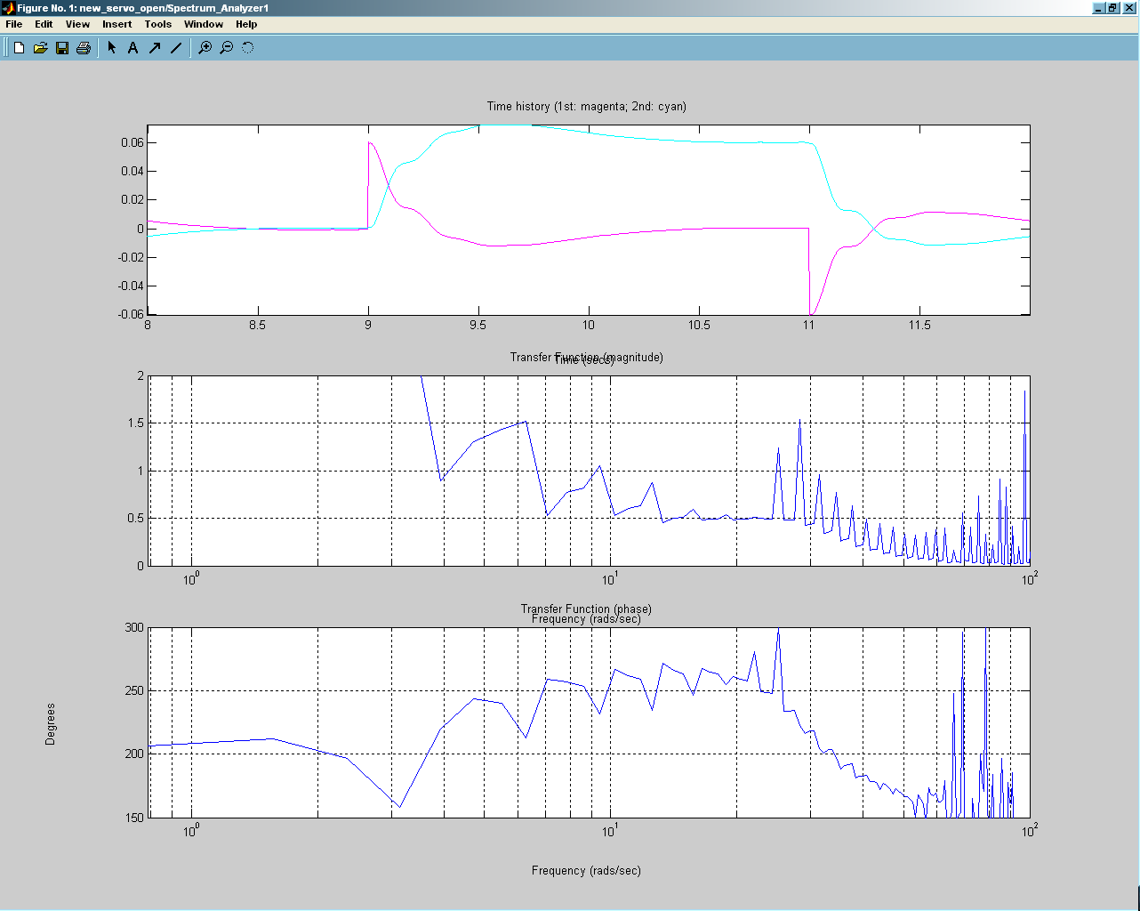
Figure 29 Proposed Open Loop Response

Closed Loop Bode Plot
The figure below shows the closed loop response of the system. The 3db point (0.707) is approximately 125Hz with the phase shift around -125°.
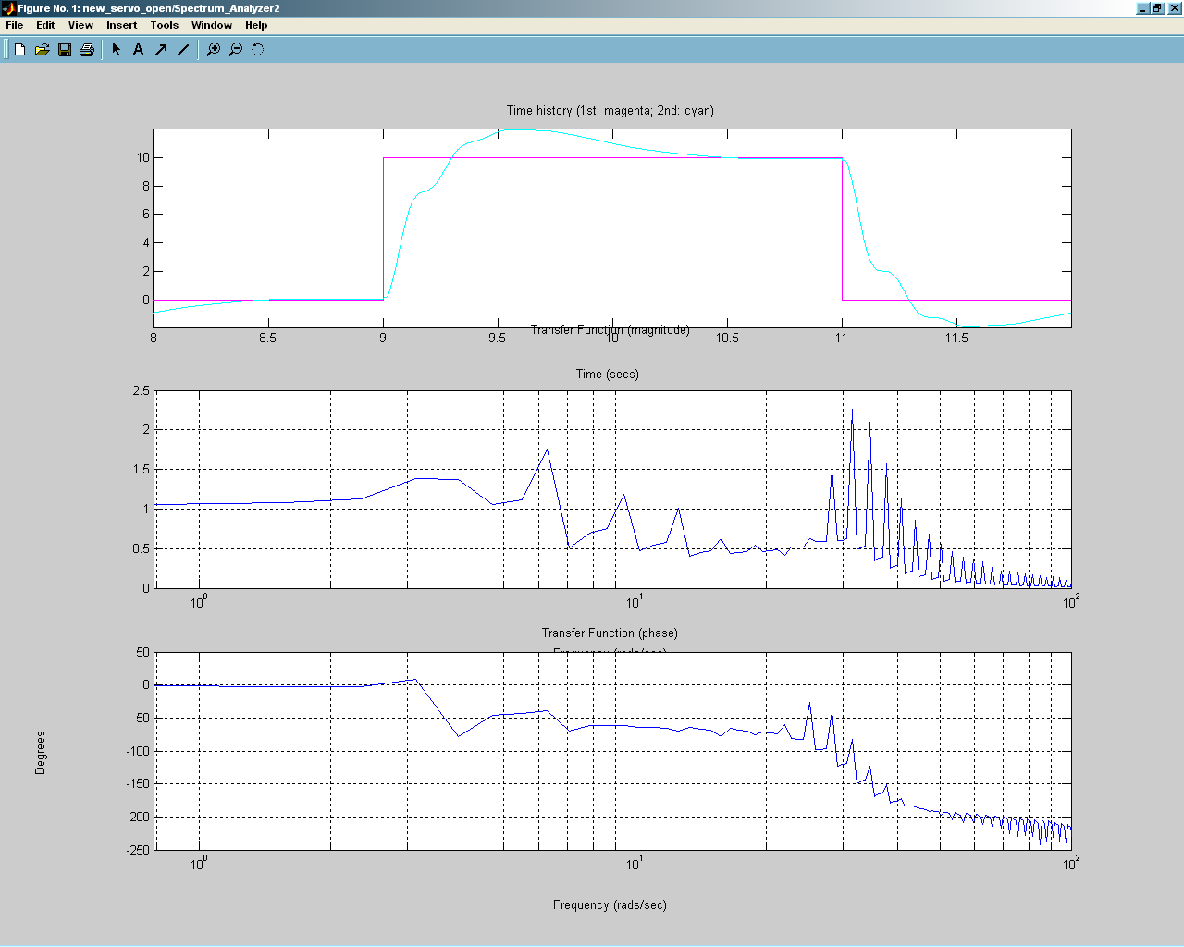
Figure 30 Proposed Closed Loop Response

Frequency Sweep
The figure below shows the placement of the spectrum analyzer block and the “chirp” sweep block used to create the open loop frequency sweep plot.
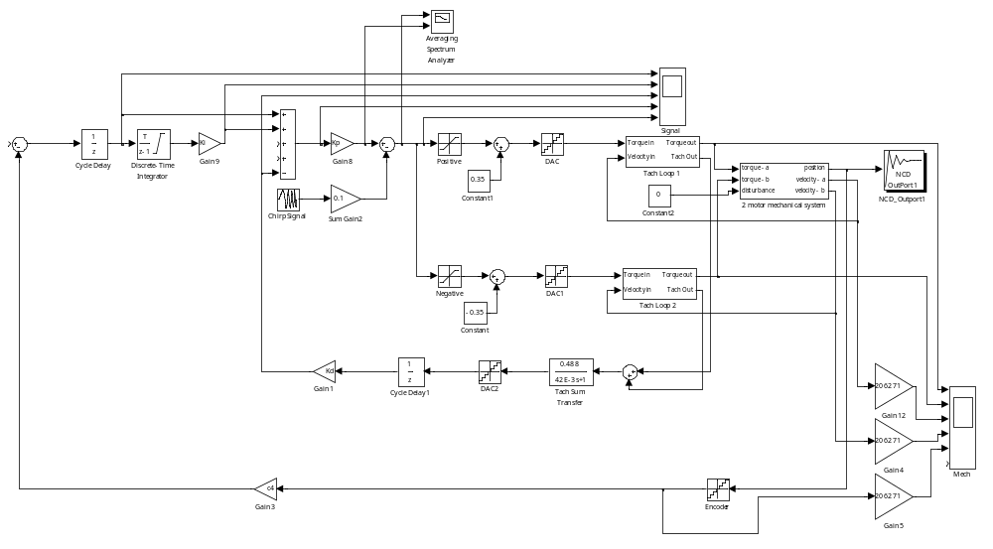
Figure 31 Proposed System in Sweep Testing Mode
The figure below shows the plot of the frequency sweep. The sweep was from 0.1Hz to 100Hz over 500 seconds. Notice a small gain peak at 1.6 Hz and more importantly the phase dip to -160 at 375Hz. Fortunately, this is far above our operating range.
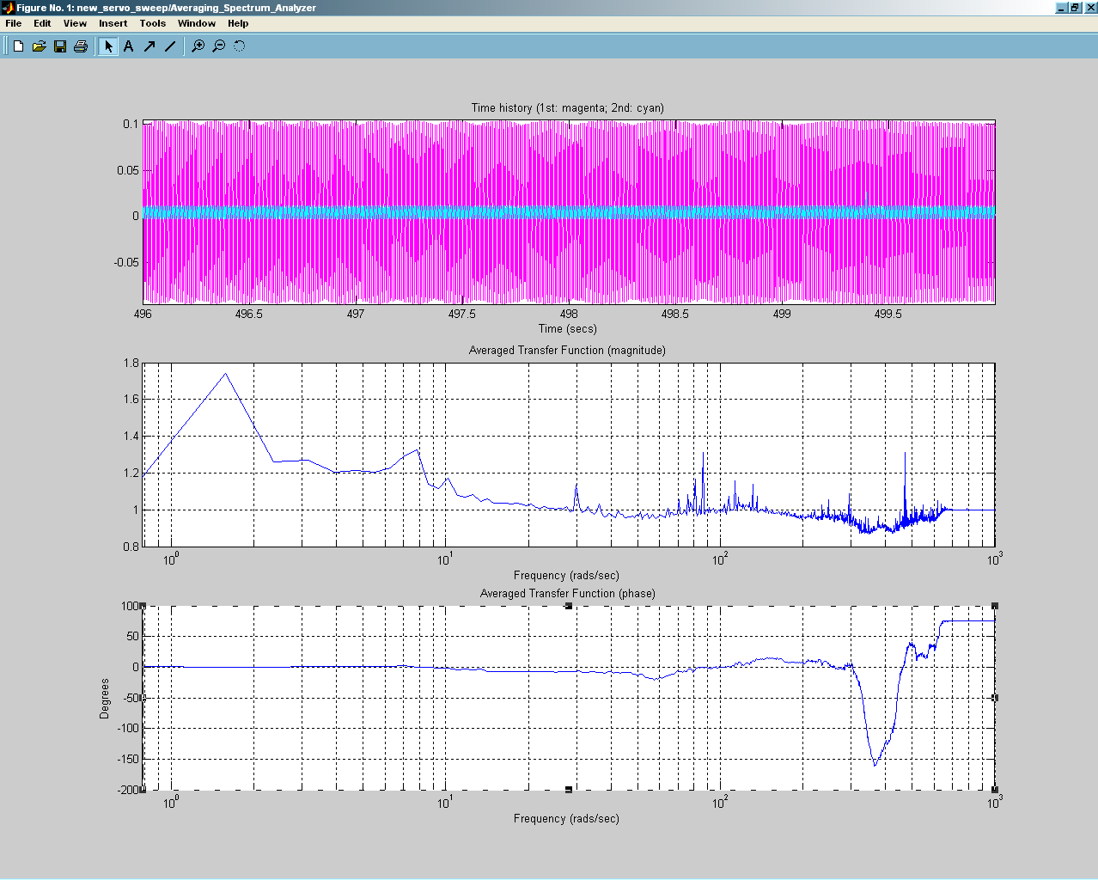
Figure 32 Proposed System Sweep Plot

Servo Data from the Present System
Data was taken at the telescope with a DAS16/16 Data Acquisition system from Measurement Computing. See References 6 and 7 for more details on test setup and data result explanations. Unfortunately, these tests were taken without the benefit of the encoder since we don’t have access to the digital signal, therefore we don’t have positional feedback. However, in the case of the offset and slew, we can determine when we meet our setpoint by looking at the motor, error and tachometer signals.

Tracking

HA
The three charts below show the HA axis in various tracking modes. The first chart shows the system maintaining position with the brakes off. The next two charts show the telescope in a 15 arcsec/sec track mode and a 30 arcsec/sec track mode respectfully. Notice the small amount of oscillation on the tachometer feedbacks. With the higher track rate this oscillation is even more pronounced. This is indicative of a control system that may be somewhat out of tune.
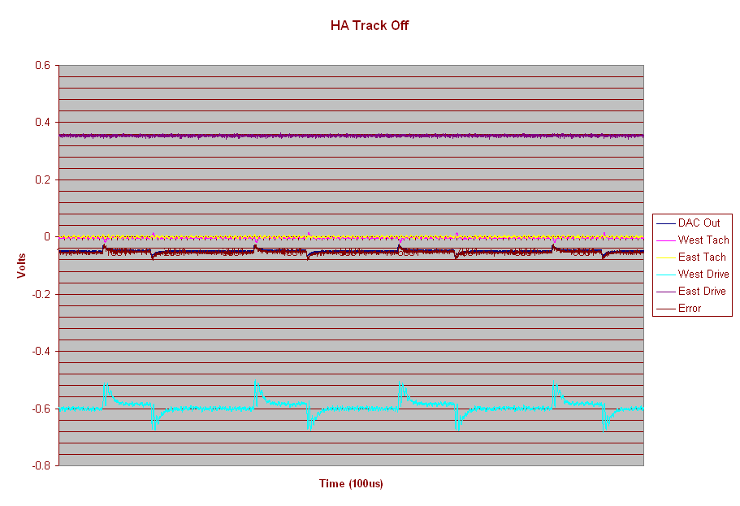
Figure 33 Track Off
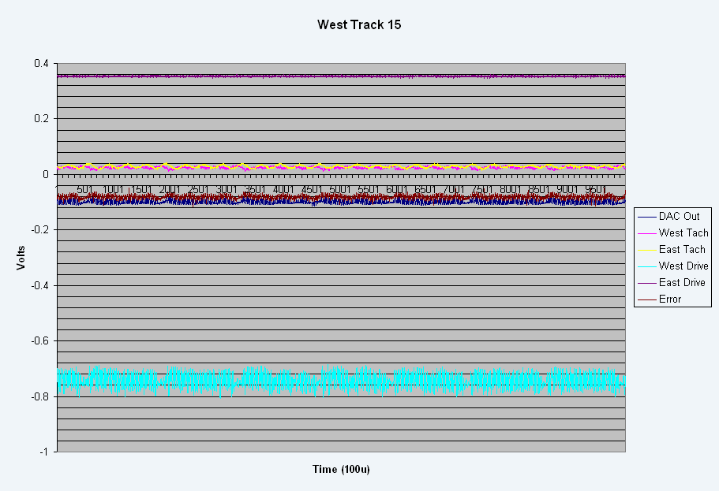
Figure 34 HA Track 15
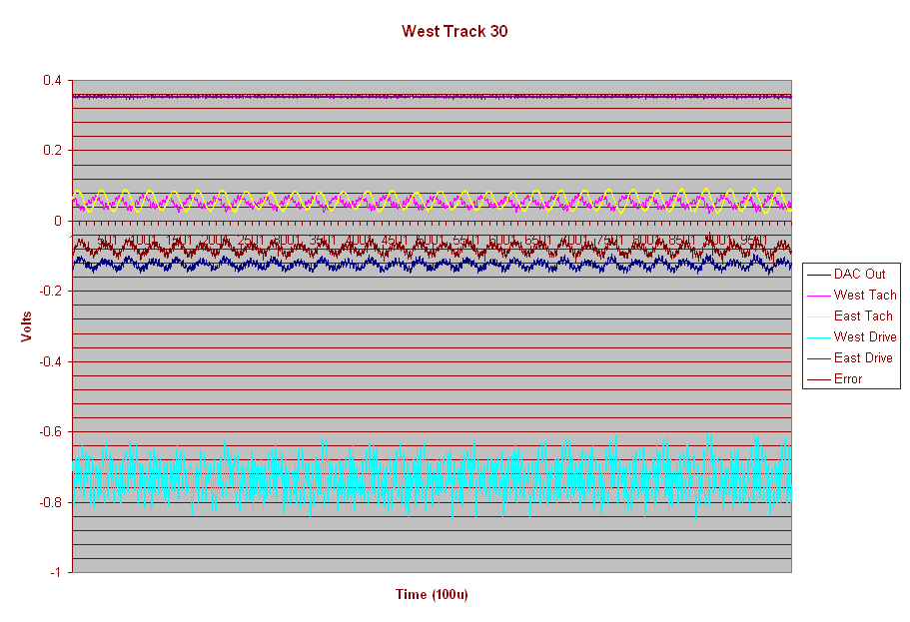
Figure 35 West Track 30

Dec
The two charts below show the Dec axis in two tracking modes. The first chart shows the system maintaining position with the brakes off. The next chart shows the telescope in a 15 arcsec/sec track mode. Notice the small amount of oscillation on the tachometer feedbacks. Once again, this is indicative of a control system that may be somewhat out of tune
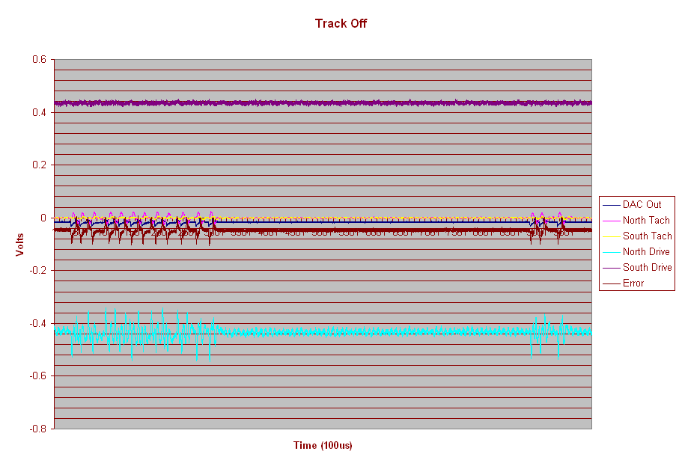
Figure 36 Dec Track Off
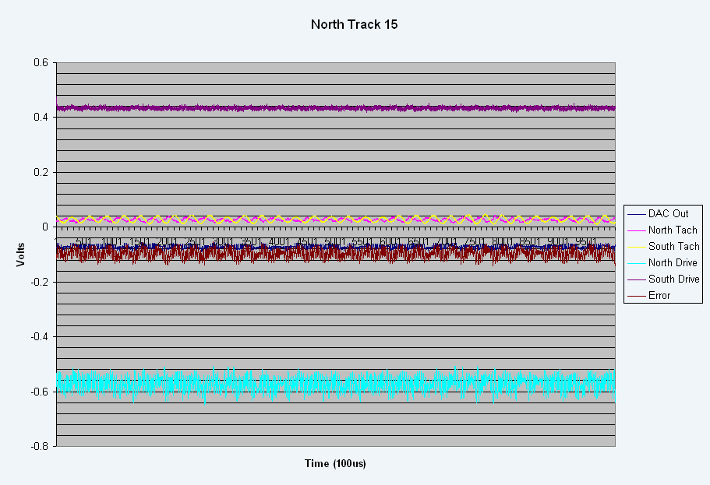
Figure 37 Dec Track 15

Offset
The following three charts show the results of performing a 600 and 1200 arcsec offset. Notice in all three charts the velocity comes down to 0 in the middle of the offset and then starts up again to finish the move indicating a problem with the system. There seems to be a fair amount of overshoot with a settling time in the neighborhood of 1.5 to 2 seconds.
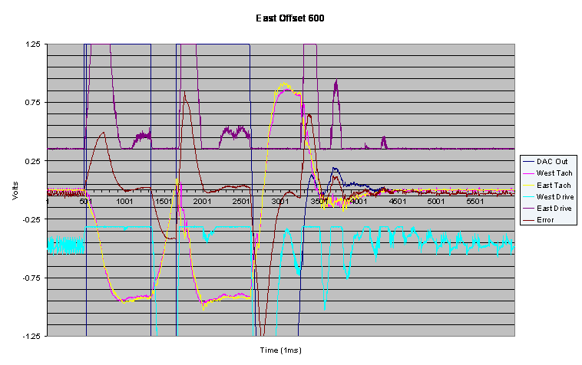
Figure 38 HA 600 arcsec Offset
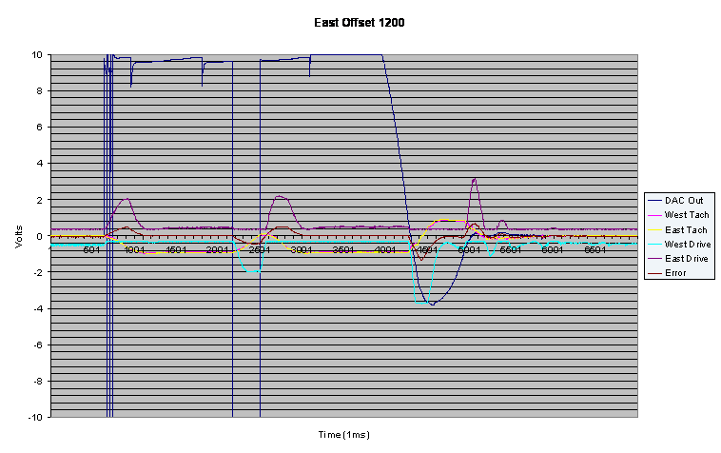
Figure 39 HA 1200 arcsec Offset
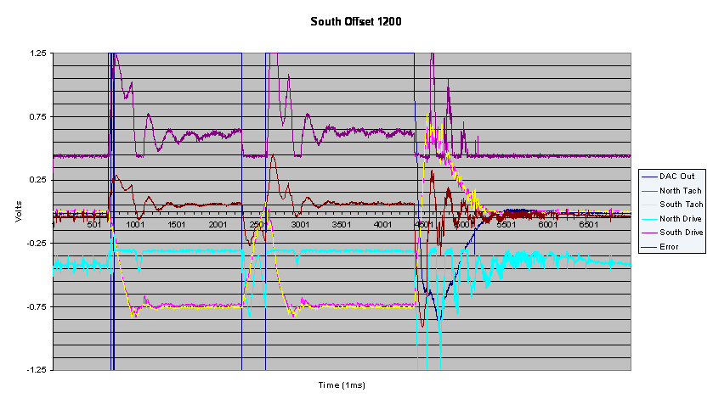
Figure 40 Dec 1200 arcsec Offset

Slew
The following two chart show a slew operation for the HA and Dec axis. As with the offset, there seems to be a fair amount of overshoot with a settling time in the neighborhood of 1.5 to 2 seconds
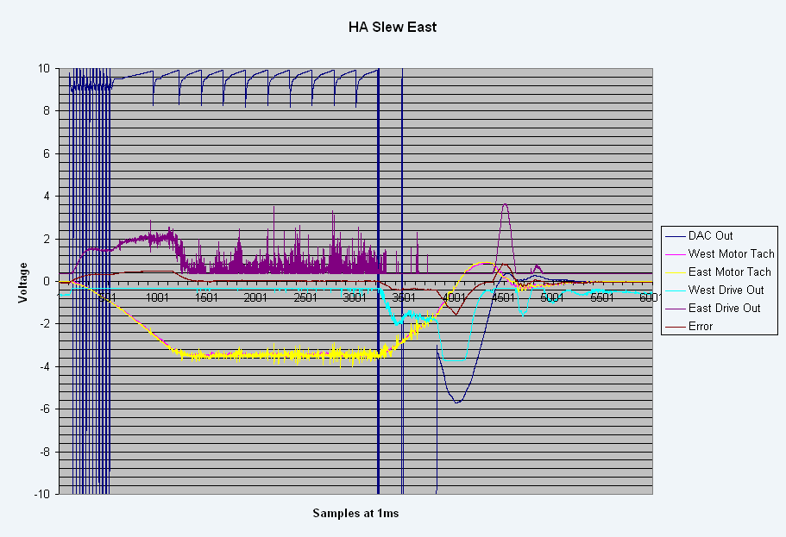
Figure 41 HA Slew
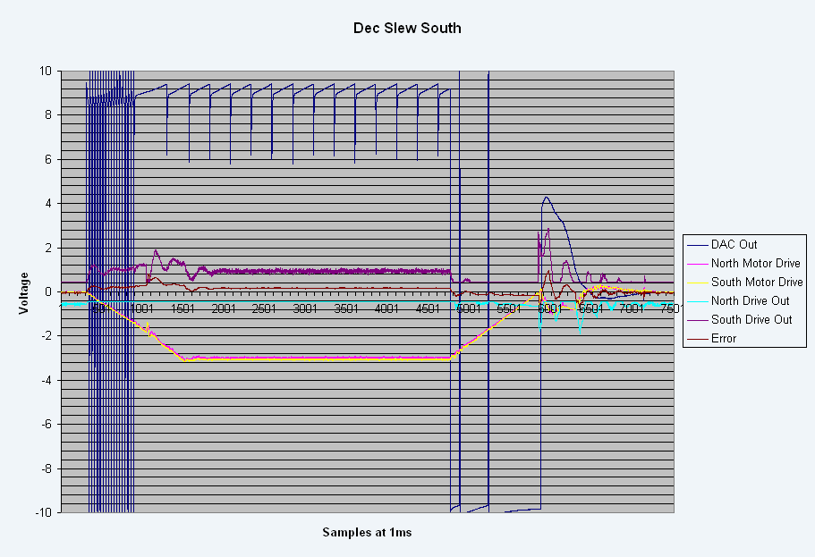
Figure 42 Dec Slew

External Disturbance
The following chart shows the effect of the HA axis from an external disturbance created from three people pushing on the telescope in the tilted position. The axis is traveling at a rate of 15 arcsec/sec. Notice the effect of the error output on the East Drive output due to the positional error. The signals are clipped at 1.25V.
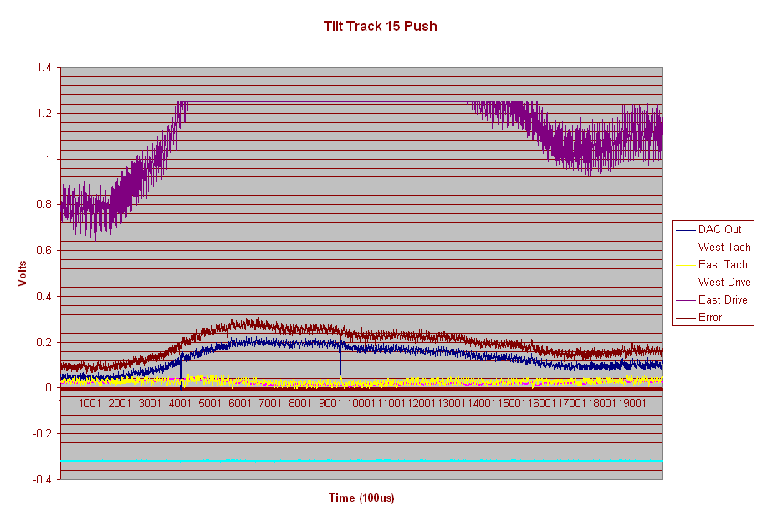
Figure 43 External Disturbance

Velocity Loop Tests
The first figure shows the effect of the system with the velocity loop completely disabled with the telescope at a standstill with the brakes off. Notice that the system goes into an oscillatory condition.
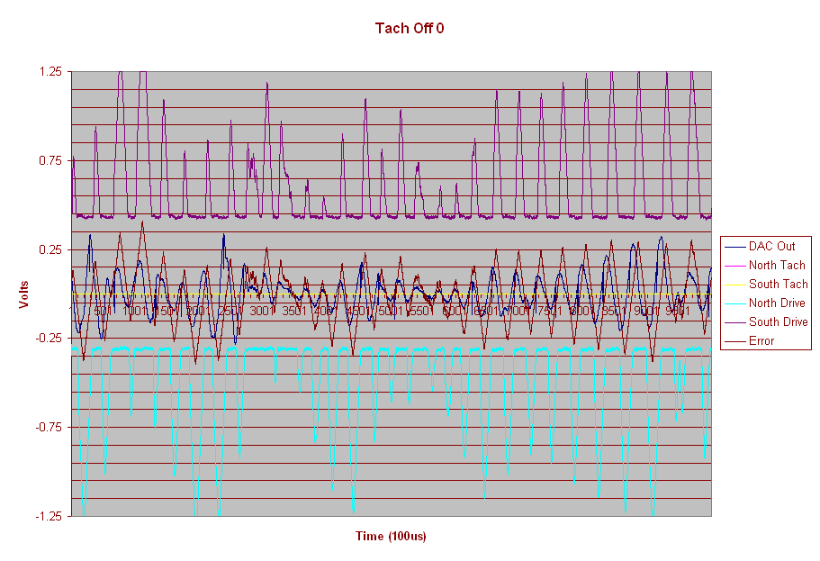
Figure 44 Velocity Loop Disabled
The next figure shows the effect of disconnecting just the 8.6Hz to 34.4Hz disturbance compensation from the velocity loop at a 15 arcsec/sec track rate. Notice the system is oscillating and out of control. The signals are clipped at 1.25V.
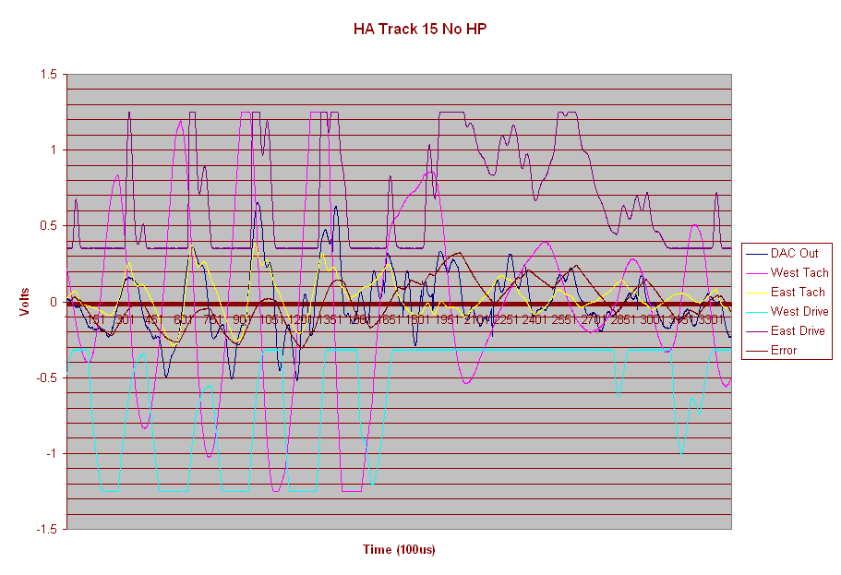
Figure 45 Bandpass Disturbance Rejection Circuit Disabled

Encoder Resolution
Listed in the table below is the RMS error in arcsecs for tracking and offset for both wind and no wind conditions for different encoder resolutions. These simulations were run for both the present system and the proposed system.
Encoder  Resolution | 1  arcsec | 0.5  arcsec | 0.1  arcsec | 0.05  arcsec | 0.02  arcsec | 0.01  arcsec
Present  System (track – no wind) | 0.260 | 0.130 | 0.032 | 0.021 | 0.023 | 0.024
Present  System (step – no wind) | 0.209 | 0.090 | 0.027 | 0.029 | 0.027 | 0.029
Present  System (track – wind) | 0.319 | 0.217 | 0.160 | 0.156 | 0.153 | 0.152
Present  System (step – wind) | 0.331 | 0.225 | 0.166 | 0.158 | 0.161 | 0.161
Proposed  System (track – no wind) | 0.260 | 0.133 | 0.037 | 0.030 | 0.026 | 0.027
Proposed  System (step - no wind) | 0.100 | 0.076 | 0.031 | 0.021 | 0.012 | 0.008
Proposed  System (track – wind) | 0.258 | 0.150 | 0.091 | 0.088 | 0.088 | 0.088
Proposed  System (step - wind) | 0.232 | 0.165 | 0.092 | 0.090 | 0.089 | 0.088
Table 1 Encoder Resolution versus System Resolution
The figure below shows the table above in chart form. As can be seen by the chart, an encoder resolution of 0.1 arcsec is the minimum resolution needed to meet the system requirements.
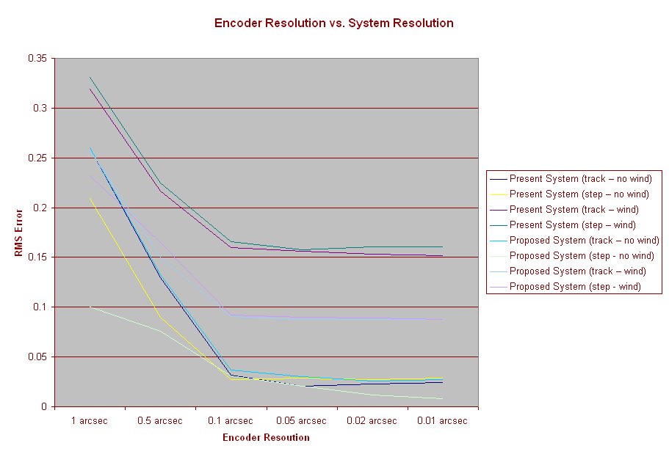
Figure 46 Encoder Resolution versus System Resolution Chart

Summary
Hopefully, the model presented here is representative of the actual TCS3 system that will be installed on the telescope and we will be able to verify the data from the model with actual data acquired from the new system on the telescope.

Resolution Requirements
As described in Appendix A of the TCS3 requirements document, there are a number of conditions defined for offsetting and tracking. Although there are a number of conditions identified, they are all based on the basic requirement of resolving to 0.1 arcsec. The simulations have shown that the present and proposed servo systems can easily resolve down to this requirement with a respectable amount of margin.

Encoder Resolution
The Encoder simulations have shown that increasing the resolution of the encoder will provide a very marginal increase in system resolution at best. In fact, for both the present and proposed systems, a 10 count per arcsec encoder would probably be sufficient to meet the overall system resolution requirement. The present encoder should be able to meet our needs.

Tachometer Configuration
The simulations have shown that the present tachometer configuration of one tachometer per motor that is summed together for an overall system velocity coupled with the individual higher frequency disturbance rejection circuits is necessary for the proposed system to meet performance requirements.

PID Parameter Values
Simulations have shown that two sets of Proportional and Integral values provide optimum performance for the system. A Proportional value of 8 and an Integral value of 2.1 are best for the step function. However, a Proportional value of 100 and an Integral value 2.8 are best for the tracking function. It is recommended that a gain scheduling algorithm be implemented for the slew, beamswitch, and tracking operations. In lieu of performing gain scheduling, compromise PI values can be used which would be a Proportional value of 50 and an Integral value of 2.8.

Wind Loading
The wind loading simulations have shown that the proposed system can better the wind loading simulation of the present system with an approximate RMS error of 0.1 arcsec.

References
- Robert E. Cory, “Dynamic Analysis of 3m Mauna Kea Telescope”, jpl Interoffice Memo, November 8, 1976.
- Tim Bond, “TCS Servo System: Mechanical Modeling”, IRTF Document, May 12, 2004, \\duke\tcs3\public_html\systems\tcs3\0405_Servo_review\bond_docs
- “Telescope Servo Control D/A, Joystick, & Integrator”, IRTF Schematic, 710-233.
- “Telescope Servo Control Tach Summer & Torque Cmd Board”, IRTF Schematic, 710-235.
- Keith Raybould, Paul Gillett, Peter Hatton, Gordon Pentland, Mike Sheehan, Mark Warner, “Gemini Telescope Structure Design”, SPIE Volume 2199
- Fred Keske, “Servo Test Data”, IRTF Document, December 11, 2003 \\duke\tcs3\ public_html\history\0312\Testdata1
- Fred Keske, “Notes on Test data taken on December 17, 2003”, IRTF Document, December 23, 2003 \\duke\tcs3\ public_html\history\0312\Testdata12

